CS166 – Modeling, Simulation, and Decision Making

Social Dynamics Simulation: Social Judgement Theory and Miscommunication

Tomer Eldor

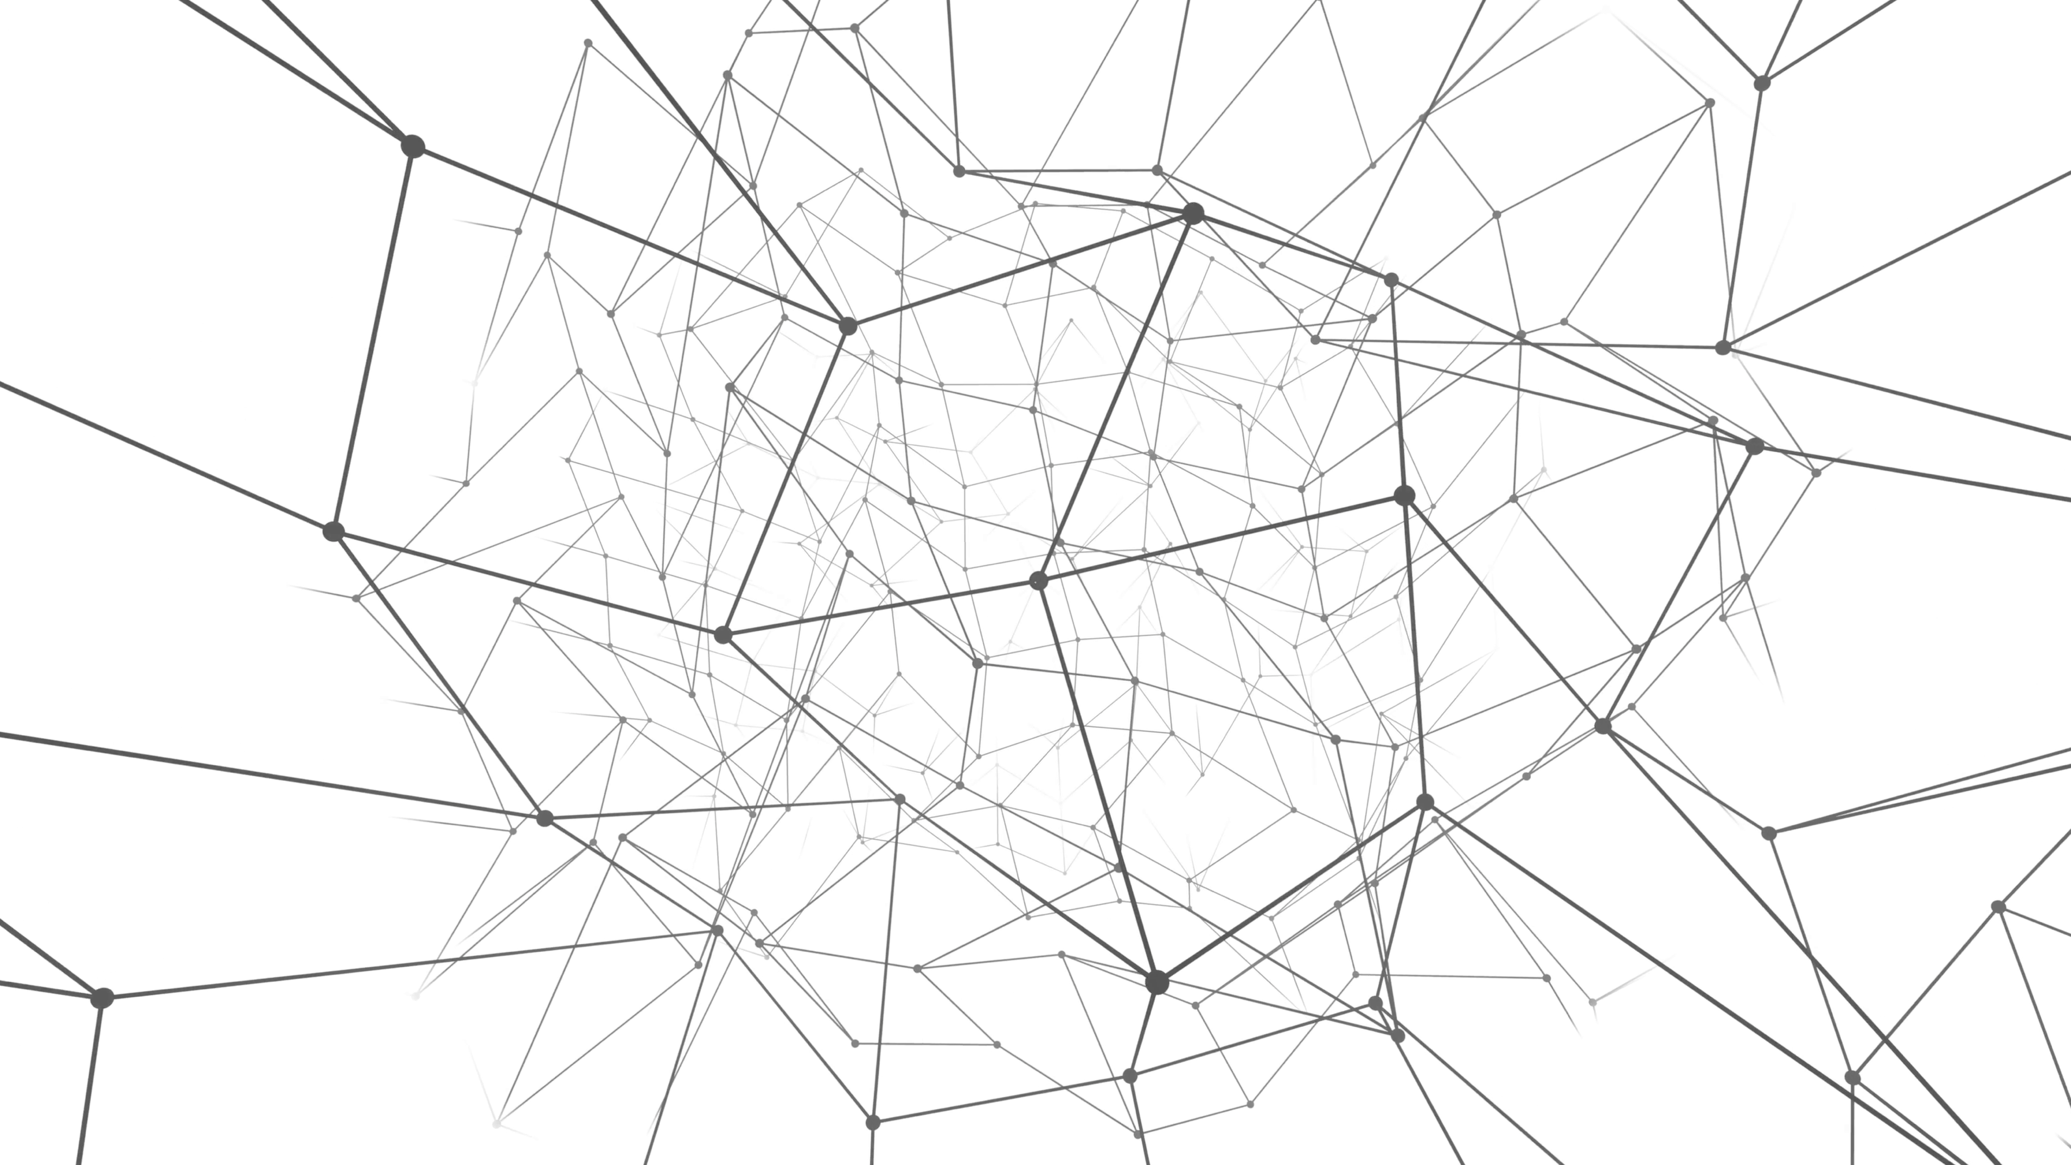

## Table of Content

Executive Summary 3

Part 1: Model Modifications 4

Modification #1: Social Judgement Theory: Latitude of acceptance, rejection, and non-commitment 4

Modification #2: Miscommunication and Misperception 5

Part 2: Local analysis 5

Mathematical Expression of Proposed Changes 5

Effects on the New Opinion 6

Opinion Change (**ΔOi**) New Functional Form 8

Effects of Latitude Modification 8

The Effect of Latitudes 9

The Effect of Misperception Error 10

Choosing Error Value for Simulation. 12

Weight Adjustments According to the Unbiased or Biased Gap 13

What happens if we adjust weight according to the to the misperceived, biased gap? 13

Choosing Parameters Values – Latitudes and Error 15

Part 3: Implementation 16

Part 4: Simulation analysis 16

Starting with Non-Extreme Opinions 16

Original Model Versus SJT Model Results 17

SJT Model with Miscommunication – Effects of Parameters 18

Key Simulation Takeaways 18

Parameters Key Effects and Critical Values 19

Takeaways 19

Detailed Parameter Effects and Critical Values 20

Clustering Coefficient and Transitivity 23

Regressions on Network Parameters 24

Improved Similarity to Real Life 24

Appendices 27

# Executive Summary

This work extends upon a social network dynamics simulation of opinion change to include elements from Social Judgement Theory (SJT) and about misperception and biases. While the original model assumes that every interaction is of accurately perceived opinions and leads to opinion convergence, we incorporate the two key elements from SJT: (1) agents change their opinions according to their latitudes of acceptance, rejection, or noncommitment; and that (2) agents experience miscommunication and misperception in their opinions, and specifically assume the effects of assimilation and contrast bias according to social judgement theory.

Key Takeaways from this extension include:

* The SJT simulation successfully modeled opinion change processes more naturally according to SJT theory and misperception bias and error, with assimilation and contrast effects, thus improved real-life relevance.
* The network exhibited many more types of end results, thus improved real-life similarity of results. Whereas the original model almost always ended in convergence (or somewhere on the way to convergence), the SJT simulation could end up at either Convergence, Divergence, Stagnation, Clustering to More than 2 Clusters, Dispersion or Dispersion with Isolation. The most common result under the attempted parameters was divergence, since the original opinions gap was 0.6, and only at 0.7 or above the simulation started potentially converging (depending on the other parameters).
* The most crucial parameter determining convergence or divergence was latitude of acceptance: only above the initial opinions gap the network *may* converge.

Key Parameter Effects:

* **Latitude of Acceptance:** critical value at the size of initial opinion gap, determining convergence potential. *This suggests that opinion change is most relevant for people who can be open-minded enough to listen and potentially accept the contrasting opinion.*
* **Latitude Variance:** determined ifopinions either converged consistently or diverged consistently or fluctuate inconsistently. *This suggests that if people have very different acceptance and rejection levels, they will not converge their opinions or form clusters, but will mostly fluctuate around their opinion.*
* **Latitude of noncommitment:** critical value at initial opinion gap size, determining if the simulation halted or significantly slowed down. *This suggests that in groups that largely don’t care about an issue unless it is extreme, extremists will either stop caring or be isolated, and the group will not move their opinions or connections.*
* **Misperception Error Bias:** increased bias caused slower convergence and faster divergence. *This suggests that people with large biases will not assimilate their opinions effectively but are likelier to get defensive and diverge their opinion in contrast.*
* **Misperception Error Variance:** determininghaving a clear trend or fluctuating around a similar value. *This suggests that groups of people with very different biases sizes are likelier to be more “confused” around their opinion as they are influenced by others, but not converge or diverge consistently.*

# Part 1: Model Modifications

The original model simplifies influence on opinion change in social networks by assuming that when two nodes interact, both agents perceive each other’s opinions accurately, converge their opinions and edge weights symmetrically. We here draw from Social Judgement Theory to reject these assumptions and instead assume that (1) agents change their opinions according to their latitudes of acceptance, rejection, or noncommitment; and that (2) agents experience miscommunication and misperception in their opinions, and specifically assume the effects of assimilation and contrast bias according to social judgement theory.

### Modification #1: Social Judgement Theory: Latitude of acceptance, rejection, and non-commitment

Social Judgement Theory ([Wikipedia](https://en.wikipedia.org/wiki/Social_judgment_theory), 2018) suggests that each person's attitude spectrum is divided into latitude of acceptance, latitude of rejection, and latitude of noncommitment. It is amongst the only theories of attitude which were empirically studied and supported with experiments.

The intuition behind this theory is that if the advocator's opinions is close to mine, I will perceive the advocator and her opinion as favorable and would naturally want to *agree* and attract, so my opinion will attract to hers. On the contrary, if the advocator’s opinion is too far (in the rejection latitude), it will be too far-fetched for me to consider, so that I would naturally resort to a defensive mode, where my stance against her opinion will strengthen and my opinion will diverge away from hers. Between those regions lies the latitude of noncommitment, which is the “gray-zone” where I don’t care about the topic or have no opinion about it; such that the advocator’s opinion will not affect my stance.

In this model, we will model each interaction between an agent and an advocator to cause a shift in each side's opinion depending on its respective latitudes as follows:

* **Acceptance**: If the advocator's opinion is in my latitude of acceptance – my opinion will shift in the direction of the advocated position.
* **Rejection**: If the advocator's opinion is in the latitude of rejection - my opinion will shift in the opposite direction of the advocated position.
* **Noncommitment**: If the advocator's opinion is in the latitude of noncommitment - there will be no change of opinion.

Thus, the most effective persuader will present her opinion as being as far away from the its listener’s opinion *within* his latitude of acceptance, keeping all other parameters equal.

Notice that the latitude of acceptance and rejection boundaries are *individual*, which may yield interesting dynamics: if Lisa has a wide latitude of acceptance whereas Bart has a narrow one, the Lisa might accept Bart’s opinion and shift towards it, but Bart might reject Lisa’s opinion, so that *both Bart and Lisa shift their opinion to be more extreme on Bart’s side*.

This poses interesting implications: if we would model topics to be correlated with latitudes, for example – politically liberal people tending to have wider latitude of acceptance than their conservative opponents, it is likely that the network will eventually resort to everyone being more conservative (similarly to the affect that stubbornness factor could make).

However, we will focus on investigating a random allocation of latitudes, uncorrelated with specific opinions or groups.

### Modification #2: Miscommunication and Misperception

The second modification will be modeling miscommunication. In real life, we almost never communicate our true opinion with 100% accuracy, nor do we perceive our partner’s opinion with full accuracy. We model this by inserting a random (normally distributed) error around each opinion when it is considered.

Social Judgement Theory also suggests a specific bias pattern to how we perceive opinions, related to the concepts of assimilation and contrast – similarly to the attitude change model.

* Assimilation: If the advocator's opinion is in my latitude of acceptance – I’m likelier to misperceive it as being slightly closer to my original opinion.
* Contrast: If the advocator's opinion is in my latitude of rejection - I’m likelier to misperceive it as being slightly further away and more to my original opinion.
* Noncommitment: If the advocator's opinion is in my latitude of noncommitment – I will accurately perceive it as staying within my latitude of noncommitment.

​

# Part 2: Local analysis

### Mathematical Expression of Proposed Changes

The original equation for a new opinion was:

$$O_{i_new}= O_{i}+α w_{ij} (O_{j}-O_{i})$$

To simulate the above modifications, I introduce two new variables:

* A “Latitude” indicator (or “dummy variable”) indicating that the gap is within the acceptance latitude by 1, gap is within the rejection latitude by –1, and gap is within the noncommitment latitude by 0 (which will be perceived without error);
* A miscommunication error term. This error term is sampled from a normal distribution around a mean of the determined “bias” magnitude that represents the size of the “assimilation/contrast” bias.

The error is subtracted from the perceived gap before calculating the opinion change, so that if the gap is within acceptance latitude, the error reduces the perceived gap, and if it is within the rejection latitude, the error increases the perceived gap. The new opinion equation will now be:

$$O_{i_new}= O_{i}+LAT•α w_{ij} \left(O_{j}-O_{i}\right)-LAT•ε$$

Where LAT is the dummy variable for latitude, and $ε$ is the misperception error.

### Effects on the New Opinion

How do these modifications change the expression of the new opinion? Within the acceptance latitude, the new opinion will increase less than it did under the original model, because of the misperception error bias making the perceived gap to be closer. Within the noncommitment latitude, the opinion will not change, making it 0, thus lower than the original opinion which would have changed more highly. Within the rejection latitude, while the original model continued to increase the opinion linearly, this new model jumps to the same value but negative and adds the misperception error bias, thus the new opinion is negatively linearly correlated with the old opinion in the SJT model.

Using [desmos](http://desmos.com/calculator), we can model the two opinion update functions and observe the differences. The graphs below represent the original *new opinion* function in red and the new SJT *new opinion* function in green.

For this discussion we first simplify the effects of $α w_{ij}$ by treating them as both equal to 1. We do this for (a) simplification, and (b) – enhancement of the resulting effect of the modifications. With the original parameters, the change of new opinion is much smaller because the effect of the gap is minimized by 0.03*0.5 (with the initial weight of 0.5 and the default setting of alpha = 0.03).

To simplify expressions and fit the formulas in the software, let us call the ΔOi, represented above as $α w_{ij} \left(O_{j}-O_{i}\right)$, as ***g*** (standing for the effect of the gap) which would be identical to the original gap of $\left(O_{j}-O_{i}\right)$. Let us call the original opinion Oi as ***x***, and the new opinion $O_{i_new}$ as **y**. I shorten LAT for ***l***. Thus, the original update function takes the form of:

$$O_{i_new}= O_{i}+ΔO_{i} ⟹ y=x+g$$

And the new update opinion function takes the form of:

$$O_{i_new}= O_{i}+LAT•α w_{ij} \left(O_{j}-O_{i}\right)+LAT•ε ⟹ y=x+lg –lm$$

Where m stands for miscommunication error, $ε$ (needed for graphing tool compatibility), and *l* (Latitude) is an indicator variable derived directly from the size of the gap g defined as:

$$l = \left\{ g≤0.4 : 1 , 0.4<g≤0.5 : 0 , g>0.5 :-1 \right\}$$

Below is an animated demonstration of the change in the new_opinion function as we increase the gap and keep the error constant. We see that the modified new opinion is higher in the acceptance latitude and shifts parallel. An error would decrease the gap between the original and modified opinion functions. In the noncommitment latitude, the original function continuous to increase but the modified one reverts to original position. In the rejection latitude, the new function jumpw to negative and *decreases*, symmetrically away from the original function. An error will increase the difference. The blue line is the original opinion function and the red line is the modified version.

[](http://www.giphy.com/gifs/27sdp2sp5Oy6atkjbW)

If you cannot see the animation, it is available [here](http://www.giphy.com/gifs/27sdp2sp5Oy6atkjbW).

### Opinion Change (**ΔOi**) New Functional Form

We can also express this in the form of the *change in opinion* as a function of the *gap in opinions.* Where in the original model this took the original form of a simple linear function (assuming parameters are constant)

$$ΔO_{i}= α w_{ij}•g$$

Where g stands for the gap in opinions. The new SJT change in opinion will be expressed as:

$$ΔO_{i}= l•α w_{ij}•g+lm$$

Where the discontinuously in *l* as an indicator variable of the size of g creates the following functional form, discussed above. Notice that we assume in this model that the effects on opinion change of being in each latitude is linear to the size of the gap and the presence in a specific latitude, so that there are significant leaps at the borders between the latitudes. Future research might want to consider assuming nonlinear, smoothened opinion change function instead, but according to social judgement theory, opinion change is linear within each latitude.

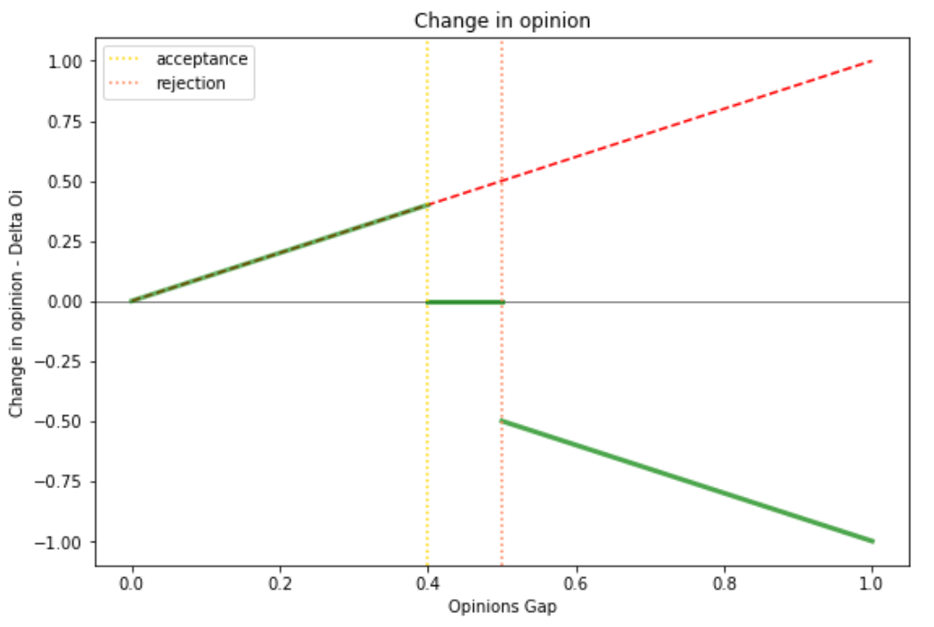

### Effects of Latitude Modification

Local simulation between two nodes showed, expectedly, that only if the initial opinions are within the latitudes of acceptance, the nodes will converge; they will stay constant if they are in the noncommitment latitude, and diverge if in the rejection latitude. If they both have the same latitudes and bias values, the change will be symmetrical. If they have different latitudes or biases, one node will change opinion more than the other: the one with lower misperception error bias will change opinion more in assimilation but less in contrast, and vice versa.

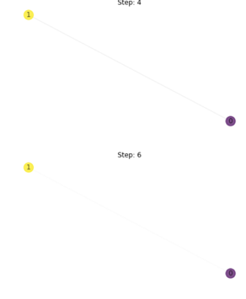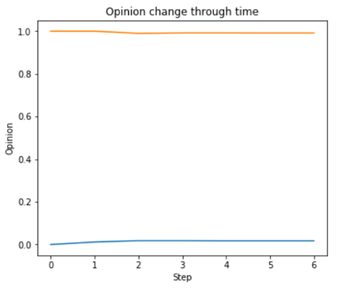

Starting simulations with the original opinions of 0 and 1, the nodes barely nudged, unless the acceptance latitude for both is the whole range of [0,1]. The weights connection weights quickly disappeared. In such case, the network nodes will not change opinions and only sever their ties to nodes with opposite opinions, staying within homogenous clusters of exterme opinions.

In reality, this suggests that according to Social Judgement Theory, if people have only extreme opinions and are not willing to accept the other extreme opinion, people will stop communicating with people with the opposite opinion, cluster only with friends having the same opinion, and thus continuously reinforce the extremeness of their opinion. This might be seen in topics that usually create extreme opinions, such as racial issues, religious issues, abortions, or sometimes party affiliation at election times.

We will set latitudes with enough variance to allow at least some nodes to have latitudes *as wide as the initial gap in opinions is*.

### The Effect of Latitudes

Using a vector field plot, we simulate how these parameters will affect the changes between opinion gaps and weights. Let us inspect the SJT latitudes simulation first without a miscommunication biased error.

Keeping a latitude of noncommitment constant at a width of 0.1, and an error of 0, we observe the following patterns as we increase the latitude of acceptance as the figures below – ordered from top to bottom (in three columns), from left to right:

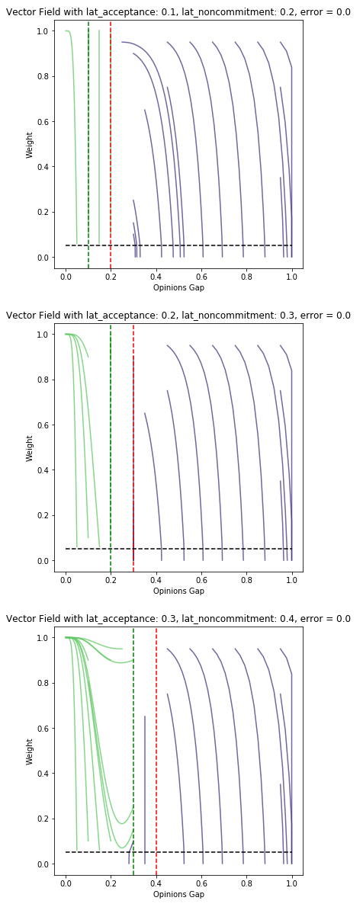 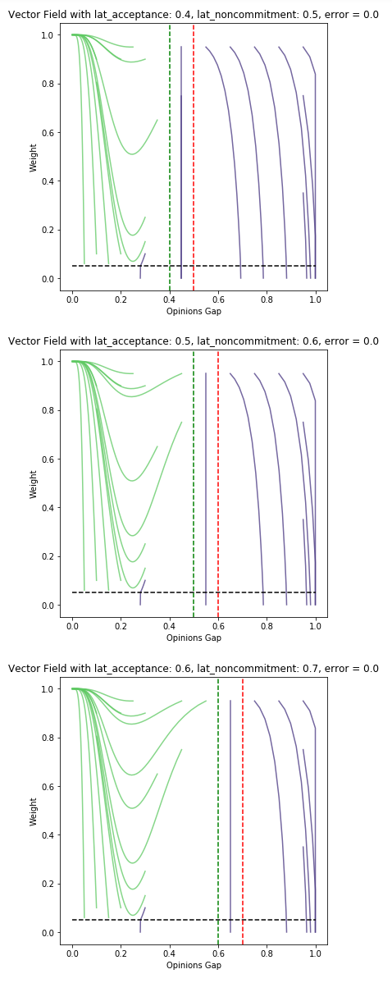 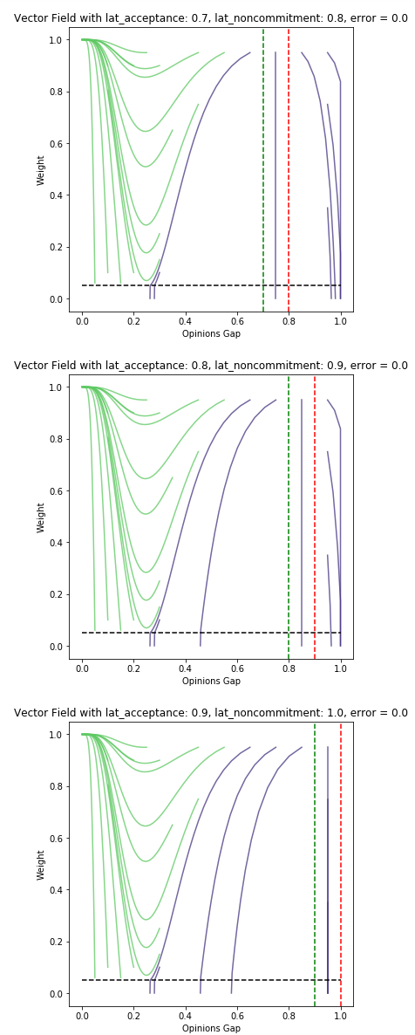

Looking at the left section, the latitude of acceptance, we see how it slowly reveals the same patterns as exhibited by the original model, because they operate exactly the same, excluding the error term.

Within the latitude of noncommitment, notice there is no opinion gap change.

Within the latitude of rejection, we observe the *opposite* pattern than in the original model, as expected by the opposite change in opinions: instead of shrinking the gap, the gap is increased, and thus the weight is sharply decreasing.

### The Effect of Misperception Error

Below are the results of increasing the values of the error.

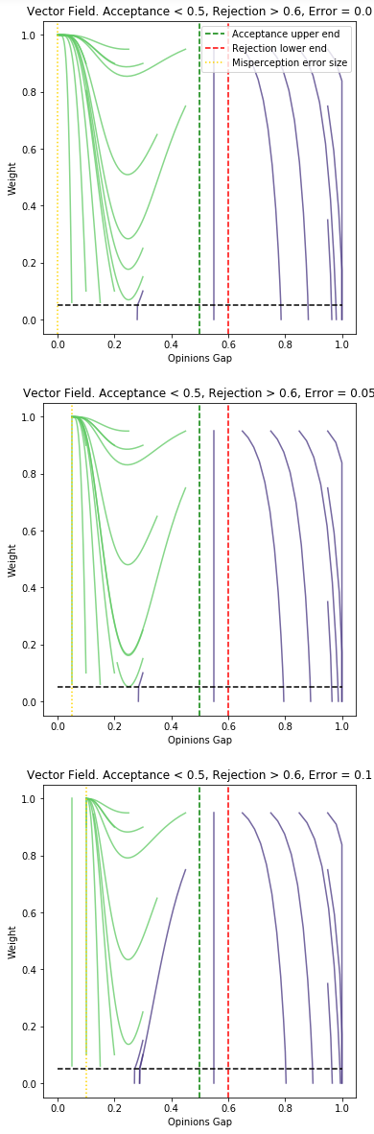 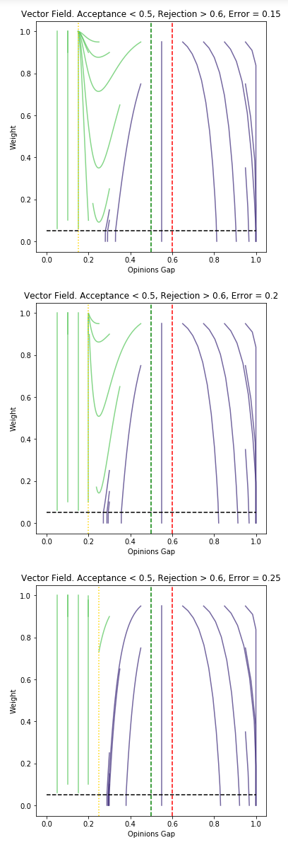 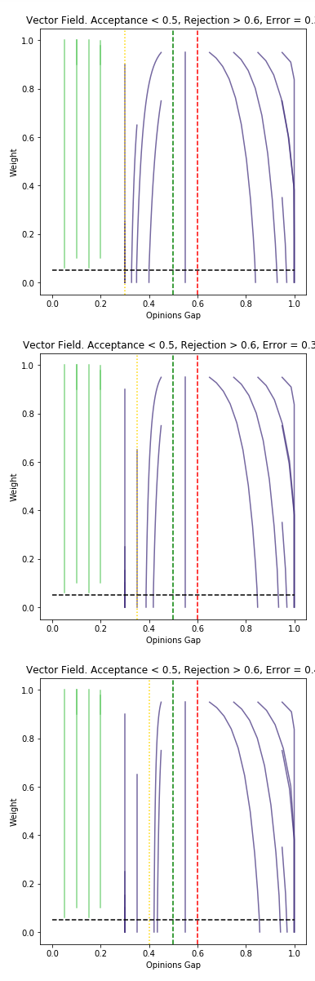

The misperception error exhibits multiple effects – first, affecting the perceived gap, and also exhibits new and pronounced effects for any opinion gap values smaller than the size of the error.

These figures demonstrate that any gap in opinions which is *lower* than the misperception error will cause the opinions to *not change.* This is because, due to the assimilation bias, if my friend’s opinion close enough to mine, *within my assimilation bias size,* then I perceive her opinion to be effectively *equal* to mine, so I don’t change my opinion.

Under the latitude of acceptance, the misperception error, through assimilation bias, makes the agent perceive a smaller gap that its real value, so that **the rate of opinion change decreases** – the opinion change is a function of gap size, and a smaller gap means smaller change of opinion.

Under the latitude of rejection, the misperception error, through contrast bias, makes the rate of opinion change increase in size (and be negative in value, as diverging opinions). This is because the gap perceived is larger than the real gap, so that the change in opinion, which is a function of the gap, is increased too. This is visible from the lines at the rejection latitude shifting more strongly sideways to the right – increasing the gap more quickly when the error is larger.

**Latitude of misperception error.** As we can see from the figures above, any opinion gaps lower than the misperception error will *not change*.

Once the actual opinion gap is low enough to be below the size of the misperception error, the agent perceives it as if *there is no gap* and stops adjusting its opinion.

This creates a pattern I suggest referring to as the **latitude of misperception error –** the latitude below which your opinions will stay constant, but not because you don’t care about the topic, have no opinion, or have an ambiguously far gap such as in the latitude of noncommitment – but rather because you fail to perceive the subtleties of the differences from your friend’s opinion, so you *can’t* adjust your own. For details on this see Appendix A.

**Implications.** These effects mean that assimilation bias in reality may cause opinions to never converge to the same exact value; but to values *within* a gap as wide as their assimilation bias. This suggests that the effects of miscommunication and our misperception biases can sabotage our efforts to learn from our friends or teacher’s opinions and prevent us from truly assimilating our opinions according of what we think we want. Moreover, we will not even notice that our opinion is different, because within the misperception error we perceive our opinion as the same.

### Choosing Error Value for Simulation.

The misperception error is sampled from a normal distribution, since we assume that in large numbers, different people will exhibit different amounts of misperception and miscommunication in a rather normally distributed fashion depending on their ability but also randomness. It is skewed according to the latitude to exhibit an average direction of assimilation or bias.[1] Estimating reasonable values of error for real-life communications, a reasonable error parameter values to start with may be a normal distribution centered at 0.05 away and with a standard deviation of 0.1. This shows reasonable distribution of errors and bias; people perceive the communication biasedly 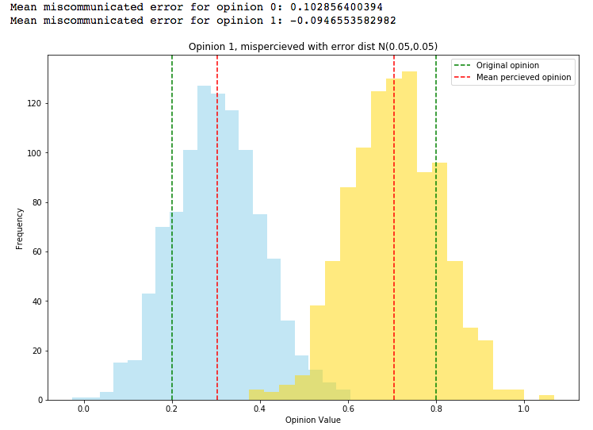around ~0.1 away according to assimilation or contrast bias. The figure on the right demonstrates this parameter distribution for both nodes simultaneously. Remember that the perceived opinion is individually set, such that the opinions would not actually cross-over each other such as might be understood from the overlap between these. The yellow opinion would be perceived as any of the yellow opinion values, but in the blue opinionated person’s eyes, his own opinion stays at the original 0.2.

### Weight Adjustments According to the Unbiased or Biased Gap

**Adjusting weight according to the real (unbiased) gap.** Because Social Judgement Theory asserts these effects and biases affect a persons’ opinion shift, but do not extend this to changing one’s relationship strength, I here assume that the weight updates normally according to the original unbiased gap, and not the biased perceived gap for attitude change. This could be interpreted as the fact that somewhere subconsciously, you might feel when there is something “not right” or some discrepancy underlying your relationship with your friend, but consciously you don’t want to admit that or detect the actual disagreement. This model could work well for highly nonconfrontational people, who will not like to even perceive or admit to themselves that there is discrepancy, but they could feel if something is not harmonious.

### What happens if we adjust weight according to the to the misperceived, biased gap?

Below are vector plots of a version of the simulation where the gap considered for adjusting weights is the same biased gap according to SJT latitudes and error:

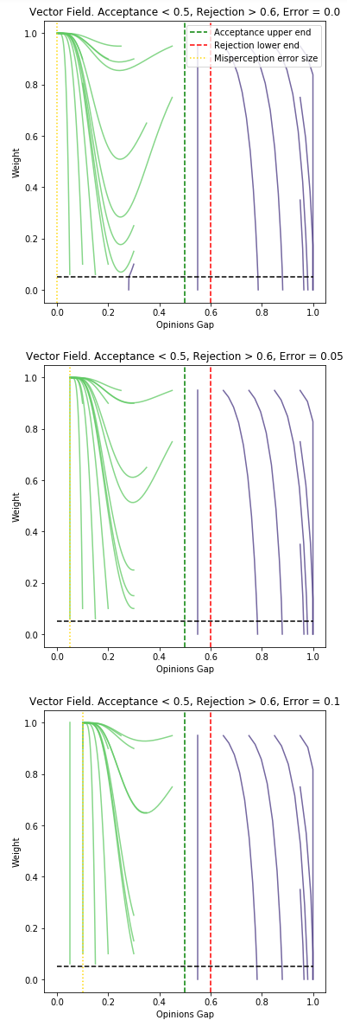 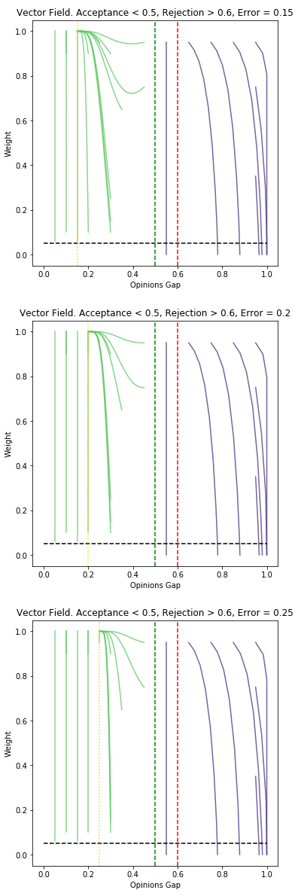 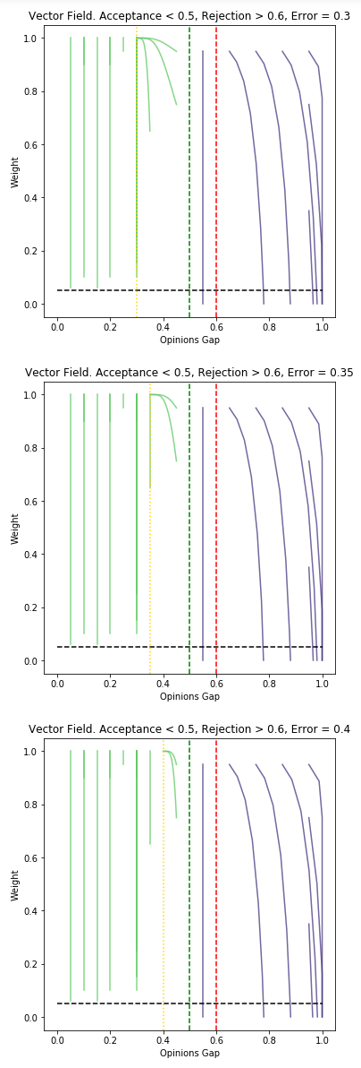

These figures demonstrate that when weights are adjusted according to the misperceived SJT adjusted value, **the effect of the original model’s critical value vanishes** (~0.23 under these settings) – the inflection point,and the behavior changes drastically for gaps between that critical value and the acceptance latitude border. When the weight change considered the real gap, this area showed *decreasing gaps and weights.* Now, this area demonstrates that *opinions within the acceptance latitude with a larger gap than the error size always end up converging to a gap at the size of the misperception error and a weight of 1, simultaneously.*

**Implication.** This model suggests that for all of your friends that hold opinions within your latitude of acceptance, you will strengthen your connections with them to be as strong as possible and converge your opinion quickly towards what you perceive is their opinion, as it changes towards your own. This might be too drastic of opinion change model than reality.

**Effects of Using Misperceived Weights on Different Latitudes.** Modifying the weight adjustment to consider the biased gap did not affect the behavior of the vector plots under different values of the acceptance latitude. Those look the same considering the real or adjusted gap.

**Assumption: Choosing to model using real or misperceived opinions gap.** I choose to model primarily using the *real*, unbiased opinions gap, because of several reasons. First, SJT suggests its biases in reference only to the opinion change, and not for the connections strength. Second, The resulting behavior, where everything under the acceptance latitude eventually converges to a weight of 1 and a gap the size of the error, is too extreme and is unrealistic. It is an extreme behavior that basically makes the latitude parameters *determine* the final results of the simulation very sharply. The previous model of behavior, where there is still some variation in behavior within the acceptance latitude, would be more interesting to model. Additionally, it is too extreme to consider as a model of real life behavior change: it makes less sense to claim what this model suggests – as mentioned before (*that* *for all of your friends that hold opinions within your latitude of acceptance, you will strengthen your connections with them to be as strong as possible, and converge your opinion quickly to towards their opinion).* The results under the original weights update seem to make a more realistic model, where you might converge your opinion and stop changing it depending on error, but you still might not be the “best friend” possible with *everyone* whose opinions are within your latitude of acceptance. We all accept opinions of people who are not our best friends (hopefully), and our connections strength with them depends *not only on their opinion value.* Although the original weights update doesn’t take into account other factors explicitly, it does seem to produce more results more likely to come from such a model, where your connection strength might decrease even if your opinions are within your acceptance latitude but are not close enough. You accept their opinions but aren’t as keen on being their best friend.

### Choosing Parameters Values – Latitudes and Error

**Errors.** The miscommunication error in real life would be normally small. However, this depends on the ability of clear communication of the speaker, and the ability of accurate, unbiased perception of the listener.

In this scale of opinions between [0, 1], the communicated opinions might be miscommunicated at around 5%, and less commonly around 10% of its value. to model the assimilation and contrast bias, I determine that this distribution of opinion with miscommunication error will be shifted 5% according to the person’s latitude. If the opinion is within the acceptance latitude, it will be misperceived as closer (assimilation). If it is within the rejection latitude, it will be misperceived as farther (contrast).

**Latitudes.** We want a small latitude of rejection, in order to not only get extreme opinions without any opinion change and lose all out-of-cluster connections quickly. Additionally, in real life, it is more realistic that people have varying opinions distributions and only become defensive and exhibit contrast effect at very extreme gaps. If we start with opinions all at 0 and 1, we won’t ever converge if they are in the latitudes of rejection. For this, we must start with values that are not only within the latitude of rejection. We could do that by either starting with opinion values that are not extreme but at anther distribution – maybe a bimodal distribution with two peaks closer to the extremes and a wide distribution of the acceptance of latitude; or a really wide variance of the acceptance latitude such that there are enough nodes with an acceptance latitude of 1 such that they would converge and “drag” their friends to converge with them.

# Part 3: Implementation

To simulate this, I use a Barabási–Albert graph because it is a scale-free network which mimics true social networks more closely. The Barabási–Albert graph uses preferential attachment to attach nodes to other nodes, such that there are many nodes with few connections, and few very popular nodes with many connections, with a power law distribution in between them. I implement a Barabási–Albert graph with 50 nodes and m parameter value of 3 (new connections), which creates the following neighbors’ distribution, exhibiting roughly a power law fitting to a scale–free network:

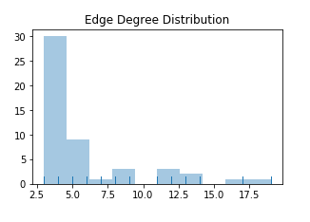

*\* Code is attached separately.*

# Part 4: Simulation analysis

## Starting with Non-Extreme Opinions

Starting with the original opinion initialization at 0,1 produced no progress in our model – only that nodes cluster in their original opinions and drop weights to the other group. For a further discussion and demonstration of this, see appendix.

In order to have variations in our model, we need the starting values to be, at least for some nodes, within their acceptance latitude. This could happen by either starting from less extreme values, or increasing the latitude of acceptance greatly, and its variance sufficiently, such that a sufficient number of nodes will have an acceptance latitude of 1, meaning that they accept anything and would shift their opinion regardless of its gap, which basically dismisses the notion of latitudes or SJT. Only then can these nodes slightly be attracted towards their opposite direction.

## Original Model Versus SJT Model Results

Modeling by starting with opinion values (0.25, 0.75), the original model quickly converged to one opinionated cluster, with nodes strengthening their connections so that edges aren’t dropped, and new edges are added. In contrast, the SJT model exhibited many different result types dependent upon the parameters settings. Under most settings with an acceptance latitude lower than 0.7–0.8 diverged away and separated into two distinct clusters of progressively extreme opinions.

Original Model SJT Model

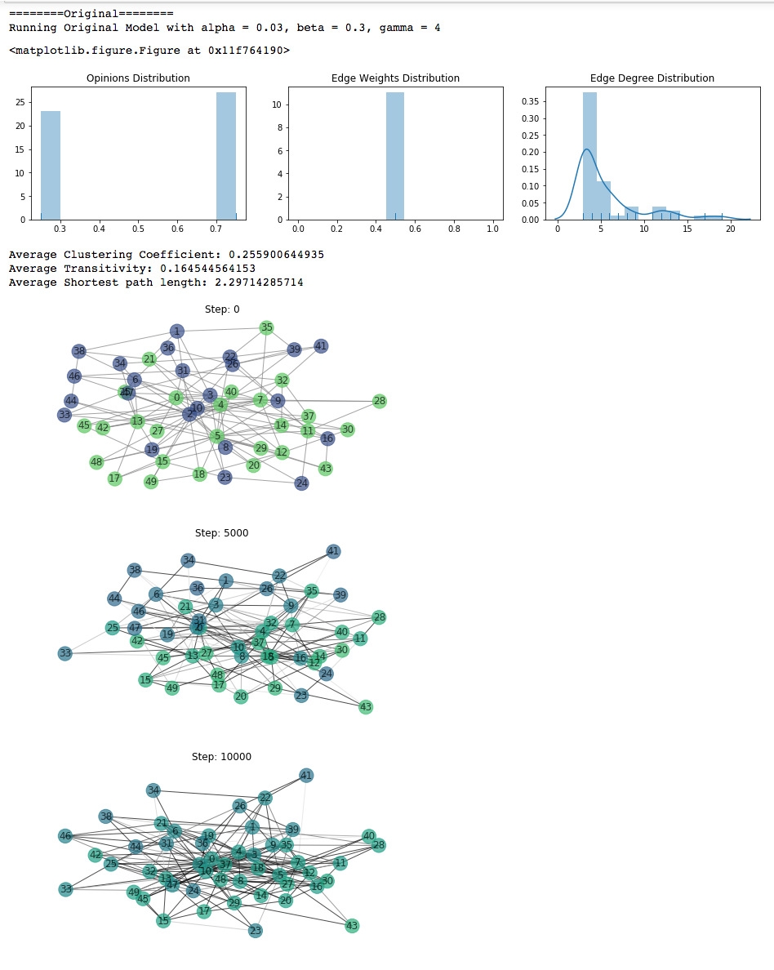 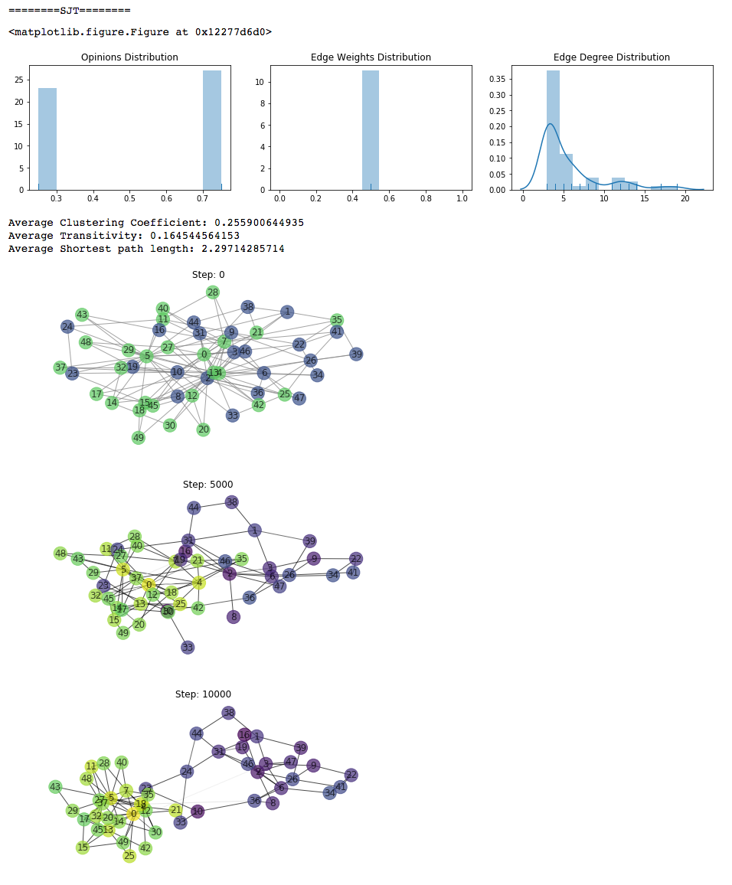

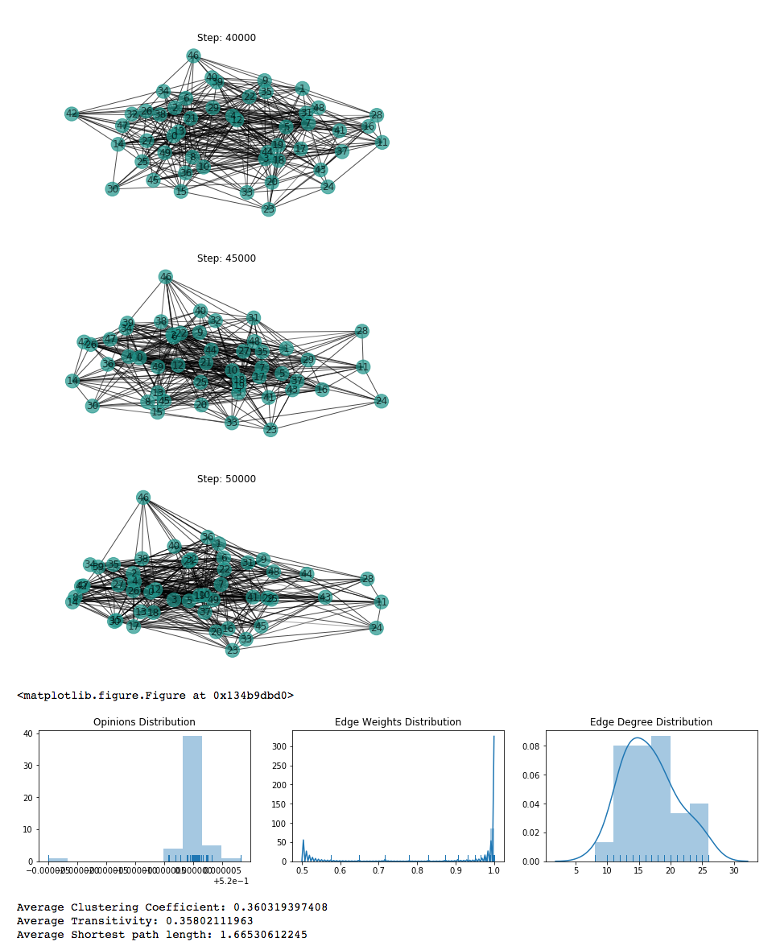 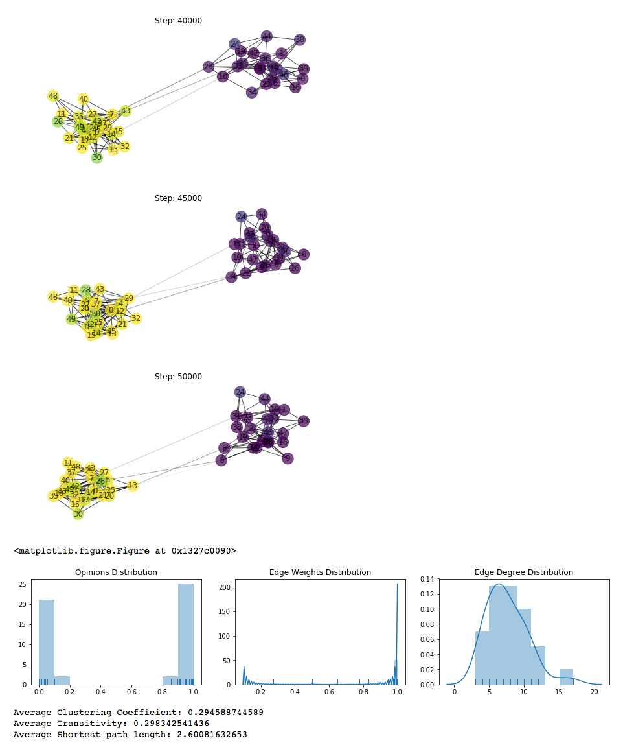

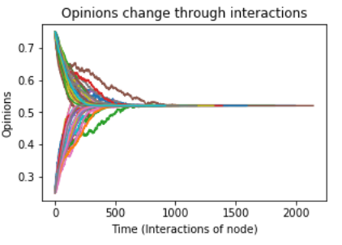 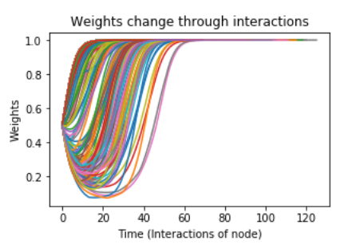 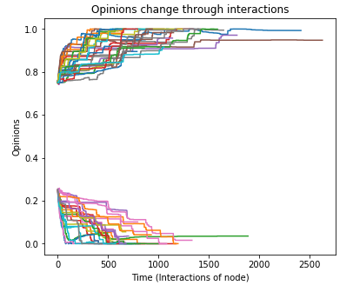 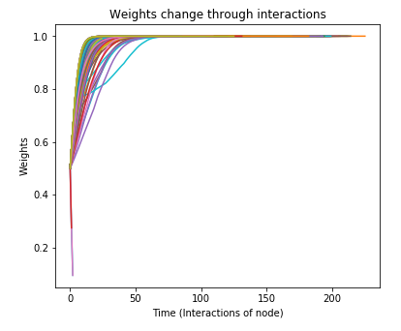

# SJT Model with Miscommunication – Effects of Parameters

### Key Simulation Takeaways

Here are the key takeaways from the overall simulation results.

* The SJT simulation successfully modeled opinion change processes more naturally according to SJT theory and misperception bias and error, with assimilation and contrast effects.
* **The most** **crucial parameter determining convergence or divergence was latitude of acceptance: only above the initial opinions gap the network *may* converge.**
* **The network exhibited many more types of end results. Whereas the original model almost always ended in convergence (or somewhere on the way to convergence), the SJT simulation could end up at either Convergence, Divergence, Stagnation, Clustering to More than 2 Clusters, Dispersion or Dispersion with Isolation.** The most common result under the attempted parameters was divergence, since the original opinions gap was 0.6, and only at 0.7 or above the simulation started potentially converging (depending on the other parameters).

## Parameters Key Effects and Critical Values

### Takeaways

* **Latitude of Acceptance: critical value at the size of initial opinion gap.** The most effective modification to achieve convergence was to increase the latitude of acceptance to higher than the initial opinion gap, 0.6. *This suggests that opinion change is most relevant for people who can be open-minded enough to listen and potentially accept the contrasting opinion.*
* **Latitude Variance: critical value at 0.4.** With a low variability in latitudes, opinions either converged consistently or diverged consistently. High latitudes variability caused opinions to progress in a less clear direction: they either fluctuated around the same constant value close to their starting point (when the misperception bias error was high at 0.3 or above) or split off from each starting point to have some nodes converging opinions towards the other cluster continuously and some nodes diverging away to the extremes continuously.

Thus, latitude variability is critical for convergence. Even with high latitude of acceptance above 0.7, variability in latitudes (of 0.4) mostly prevented the network from converging. *This implies that if people have very different acceptance and rejection levels, they will not converge their opinions or form clusters, but will mostly fluctuate around their opinion.*

* **Latitude of noncommitment: critical value at initial opinion gap size.** If the initial opinion gap is exactly contained within the latitude of noncommitment for most nodes – the simulation will stay stagnant from the beginning. If it is very wide, the simulation will reach it and stop updating or slow down significantly around these values. Extreme nodes either converged or were isolated. *This implies that in groups that largely don’t care about an issue unless it is extreme, extremists will either stop caring or be isolated, and the group will not move their opinions or connections.*
* **Misperception Error Bias: critical value at 0.3.** increasing misperception error bias above 0.3 while keeping its variance low enough *reduced the rate of convergence but increased the rate of divergence*. True convergence only happened with small misperception error bias of 0.1, around the critical acceptance latitude values *This means that people with large biases will not assimilate their opinions effectively, but are likelier to get defensive and diverge their opinion in contrast.*
* **Misperception Error Variance: critical value at 0.4.** For large misperception error bias size, increasing the variance of the error made opinions fluctuate around a constant value or slow down their trend rather than having a clear trend.

### Detailed Parameter Effects and Critical Values

I simulated for opinions starting at 0.2 or 0.8 and recorded a dataset of the parameters used for simulation; final state graph attributes of clustering coefficient, transitivity, and Assortativity of ‘opinion’; and descriptive statistics of the final state such as mean, mode and variance of opinions and weights, the 4 most frequent opinion bins and their variance, and most common degree. However, none of these parameters directly translated to the ending state of the network, so I extended the analysis by manually inspecting the resulting network structure, clusters, divergence/convergence, the progression of opinion change, progression of weights change, progression of gaps change, ending isolation of nodes (how many nodes ended up with 0 edges), and homogeneity amongst opinions in clusters.

The dataset of each of the primary combinations of parameter values from the first analysis and the extended manual qualitative analysis can be found [here](https://docs.google.com/spreadsheets/d/1TuE0Ho2ydFaKr66AflLsdnPkHjB7-Xn8V051Lrt2Gus/edit?usp=sharing).

1. **Latitude of Acceptance.** The most effective modification to achieve **convergence** was **to increase the latitude of acceptance to higher than 0.6, the initial opinion gap**.
   1. **Up to latitude of ~0.5**, the network diverged into two distinct clusters around opinions of 0 and 1 in most cases (by cases I mean various permutations of values of the other parameters).
   2. **At acceptance latitude of 0.5 – 0.6** the simulation final state highly depended on other parameter values:
      1. With a small and consistent noncommitment latitude, allowing for a large rejection latitude, the simulation still diverged to two extreme clusters.
      2. With a small but *highly variable* noncommitment latitude (width of 0.1, so rejection border is centered around 0.6, but with a standard error of 0.3), nodes *mostly stayed with constant opinions (with mild fluctuations) but* dropped edges with nodes of the other opinion and continued interactions only with nodes of their own kind.
      3. With high variance of latitudes and small misperception error and variance, the nodes diverged into clusters with high in-cluster variance towards the center of 0.5. This is a borderline case since if they would converge slightly more, the opinion distribution would have been more uniform and potentially the connections might have been less clustered in 2 clusters but more interconnected. This happened for both low and high noncommitment latitude between 0.1 – 0.3.
      4. Some cases with high variability of latitudes exhibited dispersion and disconnection of nodes: dispersion happened to both extremes yet still having many nodes with medium opinions. Those medium opinions would tend to peak around 0.5 from bottom or above, sometimes to form presumably a third cluster – when the misperception error bias was increased to at least 0.3; regardless of its variance or the noncommitment latitude size.
   3. At **acceptance latitude higher** **than 0.6**, the **network started converging**. This happened because the initial opinion gap was 0 or 0.6 (since opinions started randomly at 0.8 and 0.2). That made enough nodes start by accepting their counterpart’s different opinion and start converging towards it in order to converge. Convergence happened when the variability of the latitudes was low (probably since with high variability we would also have many nodes with lower acceptance latitude below the critical value), and acceptance latitude was at 0.7.
      1. Most other permutations of parameters under acceptance latitude of 0.6 – 0.7 lead to nodes mostly staying in their opinions (with fluctuations around it) and dividing into their respective clusters with similar or identical opinions to the starting position.
      2. When the variability of latitudes was high and misperception error bias was high (yet low error variability, and either narrow or wide noncommitment latitude) – the simulation still diverged into clusters with more extreme opinions towards 0 and 1.
2. **Latitude Variability.** With a low variability in latitudes (standard deviation of the distribution from which latitude border is sampled), opinions either converged consistently or diverged consistently. High latitudes variability caused opinions to progress in a less clear direction: they either fluctuated around the same constant value close to their starting point (when the misperception bias error was high at 0.3 or above) or split off from each starting point to have some nodes converging opinions towards the other cluster continuously and some nodes diverging away to the extremes continuously.
   1. *This makes sense because when latitudes are consistent and mostly symmetrical between clusters, then the size of latitude of acceptance more clearly determines the acceptance/rejection of the opinions, which in turn determines rejection or convergence.*
   2. Lower latitude variability of SD=0.1 or lower, on acceptance latitude of 0.6-0.7, enabled convergence. Convergence didn’t happen in any of the 24 tested cases with the same parameters but higher latitude variability.
   3. Higher latitude variability of 0.4 or higher enabled ***dispersion and disconnection*** of nodes. This happened for 4/24 cases with SD=0.4 while not once for low latitude variability of SD=0.1 – when noncommitment latitude was narrow (0.1), and acceptance latitude was up to 0.5.
3. **Latitude of noncommitment.** We keep this latitude reasonably low for most simulations, since this should be more realistic, and widening it would just stagnant the opinions and halt progression of the simulation.
   1. Its effect on the end state of the simulation is dependent upon the sizes of the other latitudes. Increasing this noncommitment latitude alone practically increases the relative influence of the larger latitude of the two active ones: acceptance or rejection. If the acceptance latitude is large and we increase the noncommitment latitude, we effectively decrease or eliminate the rejection latitude, in which case the simulation will converge, as long as enough nodes will perceive the initial gap as within their acceptance latitude. The opposite happens with a larger rejection latitude and resulting divergence.
   2. If the latitude of noncommitment is wraps around the initial gap of opinions, 0.6, and is wide enough to cover most nodes even with its variability in size and misperception errors – the simulation will stay stagnant. This means that no person cares about the different opinion of the other group, so they don’t change their opinions accordingly. They change their opinion according to their own group opinions, but those are all centered around the same initial value (including misperception error which decreases the perceived gap), so they stay around their own initial values. Basically, with a large enough noncommitment latitude, people don’t care enough and don’t change their opinions.
   3. 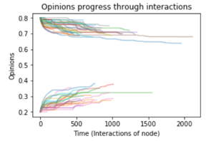**Shape of progression of opinions**. with a larger noncommitment latitude and smaller variance for it, the opinions progressed with many more constant plateaus in their progression history, basically halting when their counterparts are within their noncommitment latitude.
4. **Misperception Error Bias.** 
   1. When latitude variability is low (0.2 or below) and the trends of convergence or divergence are low – increasing misperception error bias above 0.3 while keeping its variance low enough *reduced the rate of convergence but increased the rate of divergence*. This happens becausethe assimilation bias on converging opinions within the acceptance latitude reduces the perceived opinion gap and thus reduces the opinion change; while for diverging opinions, contrast bias increases the size of the perceived gap, so opinion change is enhanced.
   2. True convergence only happened with small misperception error bias of 0.1, around the critical acceptance latitude values. With larger acceptance latitude values than 0.8–0.9, the acceptance latitude was sufficiently large to cause convergence regardless, since the initial gap is of either 0 or 0.6, so the misperception bias will be of assimilation, driving more towards convergence.
5. **Misperception Error Variance.**
   1. For large misperception error bias size, increasing the variance of the error made opinions fluctuate around a constant value or slow down their trend rather than having a clear trend.
   2. For acceptance latitudes slightly smaller than initial gap (0.5 tested below), wide noncommitment latitude and wide variability of latitudes, increasing the variability of the misperception error actually *stabilized* the opinion change to be more constant, the weights to clearly increase or decrease only at the beginning instead of large oscillations, and the gaps to stabilize and stay normally lower, for nodes from the same cluster. This high error variability seems to counteract the variability of the latitudes near their critical value. The small error variability in such contexts lead to dispersion and isolation of nodes, with two clusters at extreme values and one wide, varied, middle-opinion cluster as shown below.

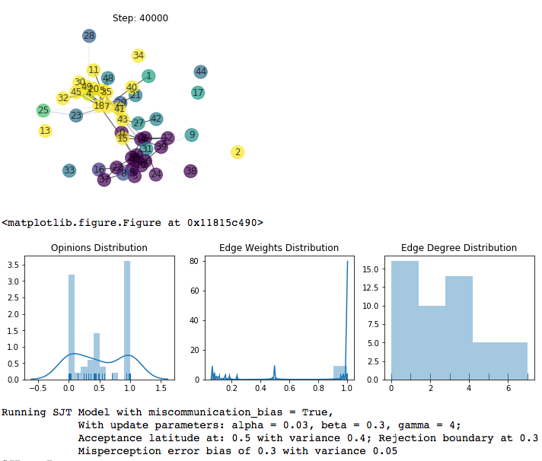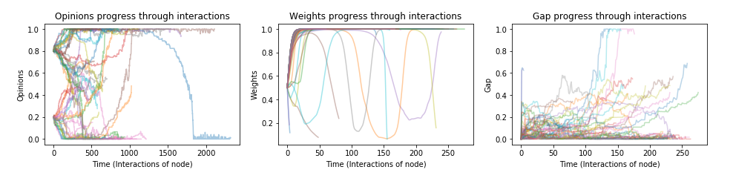

* 1. Instead, increasing the error standard deviation above 0.25 cause opinions to stagnant and the network to separate to the respective clusters of the initial opinions. 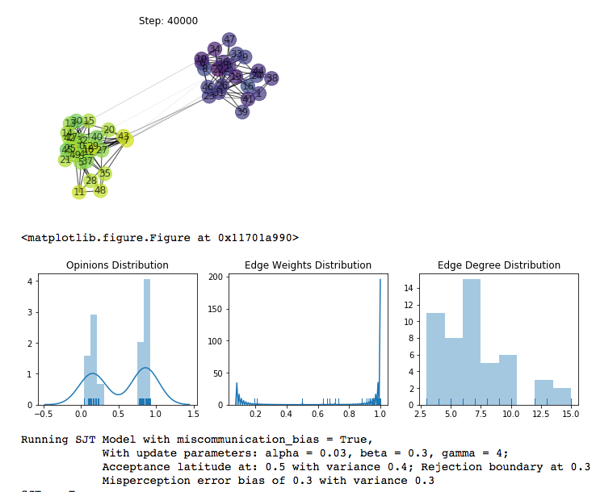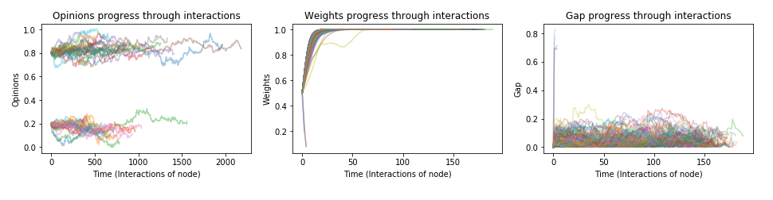

### Clustering Coefficient and Transitivity

Both clustering coefficient and transitivity are metrics to measure the level of “clustering” the network possesses, by measuring how likely it is that a node’s neighbors are directly connected to each other (have edges between them) – this is calculated for pairs of nodes in the clustering coefficient and for triplets of nodes by the transitivity metric.

The clustering coefficient wasn’t drastically changed by the SJT simulation. It mostly resulted at between 0.2-0.27, for most examples which created clusters. Transitivity also was centered between 0.2-0.27 with a few lower outliers. The lower outliers in both clustering and transitivity were the cases or more dispersion of nodes into a wide range of opinions and having many more isolated nodes or nodes with a degree of 1.

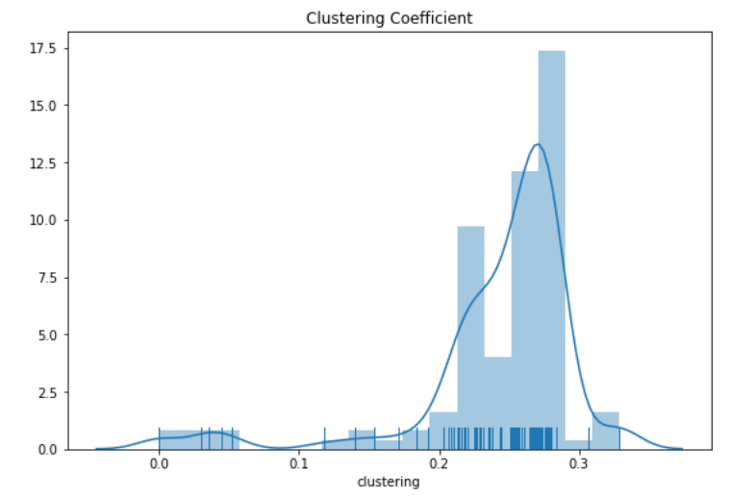 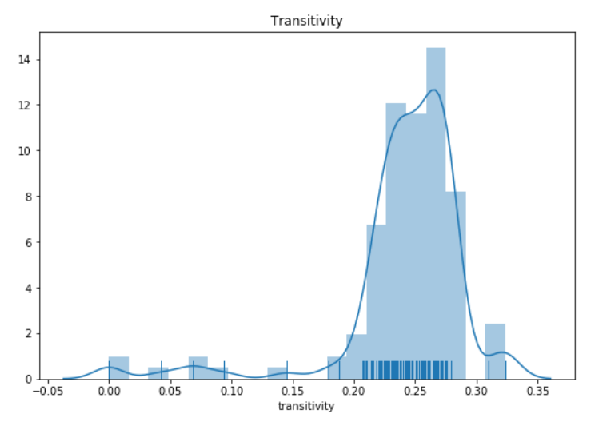

Since the dispersion and divisions to mode clusters happened mainly with lower acceptance latitudes, we can see that when the acceptance latitude is high, the network’s clustering coefficient and transitivity split off and start decreasing and creating more stochastic patterns; where the other parameters of the simulation affected the resulting clustering and transitivity significantly.

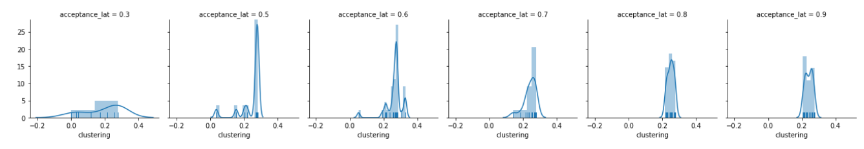

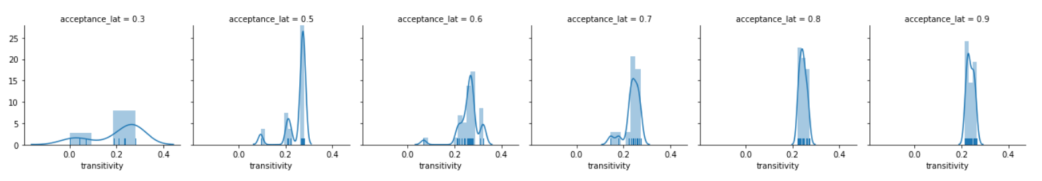

### Regressions on Network Parameters

Running regressions including polynomials and interaction variables on the metrics of clustering coefficient, transitivity and Assortativity of opinions, showed very low R2 results for all three (0.1 – 0.3), regressing upon our SJT parameters. Below is an example of the highest R2 valued regression (still with a similarly low Adjusted R2 to all other regressions). Therefore, I could not make valid conclusions about the effects of different parameters on these three metrics. From close manual analysis, I also could not find a clear trend between any of the parameters and these metrics. Regression results are in appendix D.

# Improved Similarity to Real Life

The original model fails to model both the subtleties and the long-term results of opinion changes and clustering of a network. Most dominantly, it suggests that opinions always attract, and given enough time, the network will eventually converge and form one big cluster, unless node weights vanish before this happens. It also assumes that people accurately assess the advocated opinion, and do not introduce neither error nor bias. These are different than real life, and the social judgement theory and miscommunication model simulates better possible outcomes.

**Improved Real-World Similarity in Assumptions and Process**

1. **Opinions do not always attract; they can assimilate, stagnate, or contrast.** The original model suggests that opinions always attract symmetrically. However, Social Judgement Theory suggests and *empirically supports[2]*; that people don’t always assimilate their opinions towards their partner. It depends, amongst other factors, on the gap between the opinions and the individual’s latitude of acceptance, noncommitment and rejection to discern how to update the opinion. As you can probably self-reflect or observe around you – you, and people around you, don’t change their opinions towards any opinion they meet; even if they know that person well. People have relationships with people that hold different opinions from them. This might not move theirs, if they are confident in it or don’t care, or this might, as in a fight, make the person defensive and subconsciously strengthen their own stance in opposition to the other person. The SJT model simulates this phenomenon.
2. **Miscommunication and misperception.** Whilethe original model assumes that people accurately assess the advocated opinion, and do not introduce neither error nor bias, this model replicates reality more closely since people (a) miscommunicate and (b) misperceive the advocated opinion. Through contrast and assimilation bias, people tend to perceive those opinions as closer to theirs if it is in their acceptance latitude and further if it is in the rejection latitude.

**Improved Real-World Similarity in Results**

1. **Variability of End-States: Convergence, Divergence, Stagnation, More than 2 Clusters, or Dispersion.** Whilethe original model only ended at convergence or divergence, depending only on the rates parameters, this model extends the factors leading to end-results and the types of end-results. Depending on these latitudes, misperception error, and their variability per individual, the model might create much different results, through the sounder opinion update processes, which simulate real life better.
   1. **Convergence.** If people hold similar *enough* opinions, and have strong enough connections to convince them to shift their opinion, then they do converge in their opinions. If the whole network does so, starting with close enough opinions, the network does tend to converge opinions, and in a self-reinforcing manner. Looking at a closed network like university, this is like the entire university has similar enough degrees of disliking a new policy, so people complain to each other and as a result people assimilate their opinions, and the more positive opinionated people convince the pessimists of some of the advantages, such that with enough interactions, the entire group reaches a consensus –assuming that everyone was willing to listen and not to extreme in their opinions.
   2. **Divergence.** If people have exterme enough opinions, they diverge in contrast and form 2 extreme camps. A classic example of this might be politics for people with strong stances. Towards elections, people’s support of their party strengthens as they reject the validity of the other party, simulating today’s political situation in the US and many other countries, with mostly two extreme camps.
   3. **Stagnation.** This phenomenon happened mainly when either (1) opinions were mostly in noncommitment latitude, or (2) high misinterpretation error and high latitude variability.
      1. Complete stagnation mimics reality better when opinion gap is mostly in noncommitment latitude. If people have somewhat different opinions about a topic but they don’t care enough about the topic to have their opinion changed, or it is a matter of taste (e.g., taste for cilantro), there is really nothing to do, and opinions would not move. They then might form clusters of people with the initial opinions (e.g., the association “[iHateCilantro.com](https://www.ihatecilantro.com/frontpage.php)”). If the noncommitment latitude is narrower for some people on other topics, then they might indeed consider the other opinion and assimilate or contrast. For example, liking of Jazz music versus Hip-Hop. They will eventually form clusters of groups who like each, but some nodes may shift towards or away from the other group by sampling Jazz / Hip-Hop, and bring other nodes with them.
      2. Small oscillations but mostly steady opinions occurred when the variability of latitudes and misperception errors was high. This mimics reality better for these cases; if two groups have different opinions but some people are highly accepting, and some are contrarians, while *also* some interactions are highly misinterpreted to either direction, then the more accepting people would be influenced but from many opinions perceived very differently to both directions. Essentially, people get *confused* around their opinion so they are *micro-influenced,* but because of these randomness and variability of influences, people’s opinion regresses to the mean.
   4. **Dispersion, Isolation, and more clusters.**
      1. Sometimes the simulation showed dispersing opinions, constantly changing and resulting in a wider distribution of opinions. Usually connections started to disappear in that case from some nodes without close friends with their opinions. This happened when people had lower acceptance latitude baselines but high variability in latitudes, varied misperception errors,

In conclusion, the SJT simulation improved our original model by the assumptions on opinion change and behavior and indeed it showed many more varied types of effects that are more similar to real life.

# 

# **Appendices**

# Appendix A: Details on Misperception Error

The misperception error’s effect creates different patterns depending on the critical value where weights under the original model previously shifted phase from decreasing to decreasing, which was around 0.23 with the current model parameters:

* For misperception error sizes *smaller* than the original inflection point:
  1. In the original model (or under error of 0), both weights and opinion gaps would decrease, to converge at a gap of 0 and weight 1.
  2. Now, *agents with opinion gaps that start below that critical value* stay constant in their opinions, with the constant gap, and increase their weight until the maximum of 1, since this is the original range where agents would increase their weight.
  3. *Agent pairs starting with a larger gap than the critical value around 0.23*, while the error is lower than this value, will converge their opinion gap in the same manner as before, such that if it starts with a high enough weight or low enough gap, it will be sufficiently high before reaching X= ~0.23 so that it can still elevate and strengthen their connection. **Their opinion gap will converge to the value of the error.** So that people’s opinions starting further apart then the perception bias could get *as close as their misperception bias range* and no more.
* For misperception error sizes *larger* than the original inflection point:
  1. Beyond this point, because the weights adjustment still occurs as a function of the real gap, the weights still exhibit the trend of decreasing at any point after this critical value. So, within the latitude of acceptance, gaps decrease but weights decrease too, and because the misperception error, the gaps fail to decrease quickly enough (because I perceive their opinion is closer than it is so its affect is diminished) and the weights decrease until they meet the error size where the agents stop updating their weights.
  2. For values larger than this critical point, the gap is considered too large for the weight change (even if the misperception error means one doesn’t perceive the subtle opinion differences well enough to change their opinions), and the weight decreases until vanishing to 0. If the weight is smaller than the error, the gap stays constant but the weight decrease. If the weight is larger than the error, the gap will decrease but not quickly enough to reach the phase shift point where weights increase again.

# Appendix B: Parameter changes – Original Model

### Original Model: Changing Parameters

**Alpha.** In the original model, reducing alpha lower than ~0.3 while keeping beta and gamma constant resulted in separation (see figure below with alpha=0.15). This reduced rate of opinion changes indeed showed in not only reduced rates of opinion change but also reduced *amount* of opinion change. This is because nodes converge into clusters of tight opinions and mostly very slowly change their opinion to converge towards the other cluster. Within clusters, the weights increased quickly to 1, and edges with decreasing weights which eventually vanished. Therefore, at least in 40,000 iterations, the model was diverged into two clusters. It may converge again extremely slowly since the original algorithm always converges towards the opinion of the neighbor. Thus, if there are still enough nodes with neighbors in the other cluster, or if random edges form between them, these nodes will sway their opinion towards the other cluster, and with large numbers of them, over time, eventually pull their cluster a little closer to the mean, until forming one big cluster.

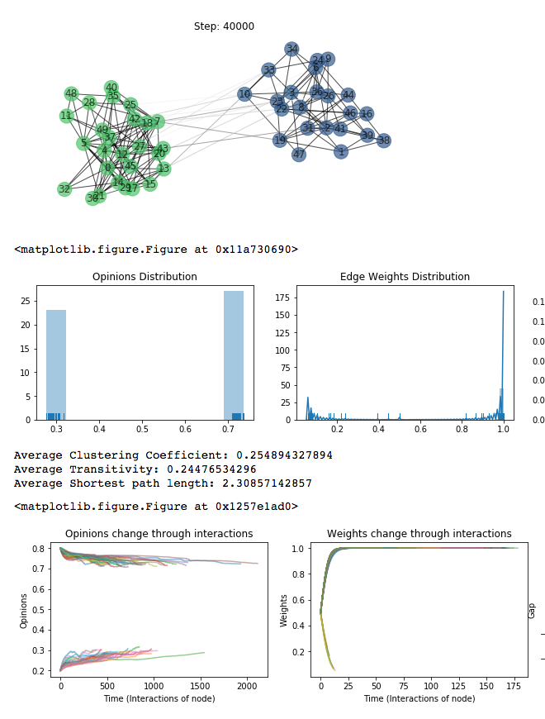

**Beta.** Since beta controls the whole magnitude of weight change directly (as a result of previous weight, opinion gap and gamma), decreasing beta decreases the rate of change of weight. However, while keeping alpha at 0.03 and gamma at 4, the weights drop much less and increase more of the time. That is because they don’t drop quickly and drastically enough to slow down the rate of opinion change with them, so opinions still converge quickly while weights adjust slowly, such that opinions already are close enough to the mean soon in the simulation (after ~4000 steps overall or about 200 interactions per node) in order to attract the weight much more positively.

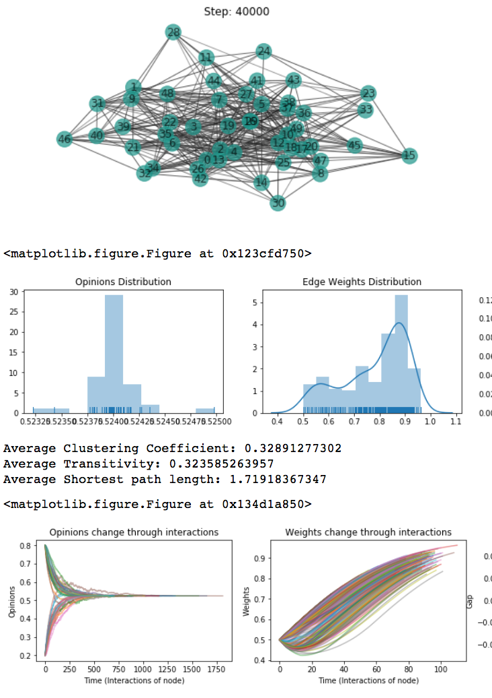

**Gamma.** Gamma controls the magnitude of the effect of the gap on decreasing weights. If gamma is larger than 1, weights will decrease if the opinion gap is large enough (larger than the inverse of the gamma). Thus, reducing gamma reduced the rate of decrease in weight, such that weights increased faster; and thus, opinions converged faster. The two left figures are for gamma = 3, and two right figures are for gamma = 4 (original setting), keeping other parameters at their original setting.

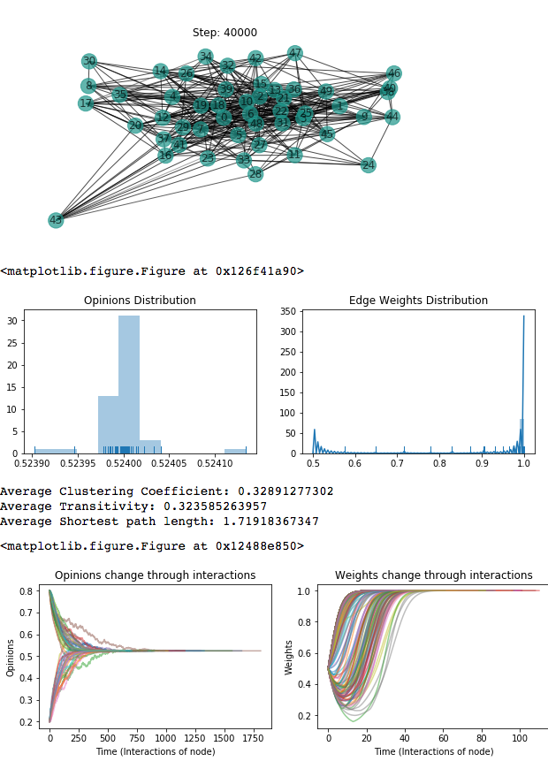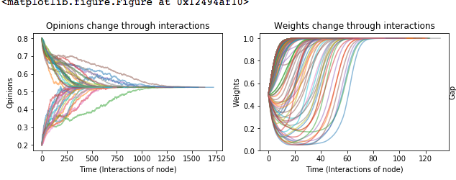

Running simulations under all possible combinations of values between alphas of [0.01 ,0.03, 0.06], betas of [0.03, 0.3, 0.6], and gammas of [3,4,5] – all simulations eventually converged to one cluster within the given 40,000 total steps (and almost entirely already by step 20,000), except for when alpha was at 0.01 and beta and gamma stayed at original values of 0.3 and 4, respectively. When alpha was at 0.01 but beta and gamma were reduced as well, to 0.03 and 3 respectively, the parameters were still at such a balance between rates of change in opinions and weights that they still shifted together; the weights were also slow to update so they didn’t immediately drop when the opinions stayed around [0,1] as it happened when we only decreased alpha; they weights very slowly updated as well together with the opinions, to form a normative process shown at the figure below.

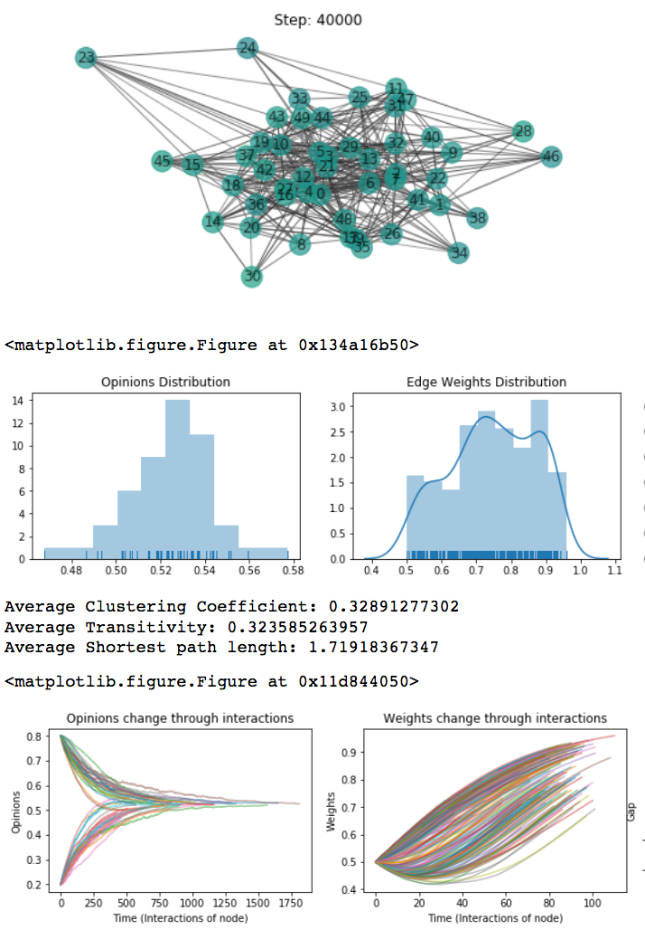

# Appendix C: SJT Simulation With Opinions [0,1]

## Starting with Extreme Opinion as in Original Model

Starting with original starting values of extreme opinions (1,0) under the SJT created separated clusters at exactly (0,1), with no changed opinions. The only change throughout the simulation was the elimination of edges between the two clusters. This is different than the original simulation because the original model still attracts opinions, but under SJT, these extreme values were within **the rejection latitude,** so that nodes’ opinions didn’t.

Below are the two variations:

### Original Model: SJT Model:

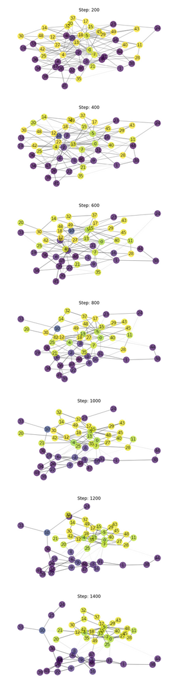 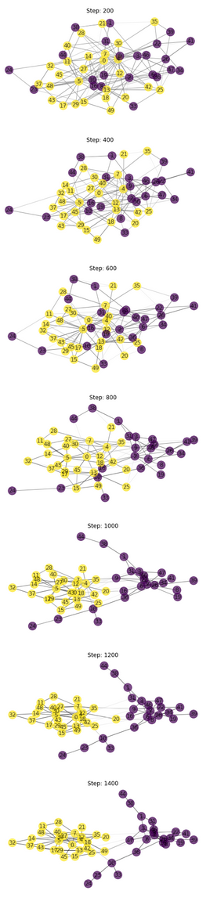

Original Model: Modified SJT Model:

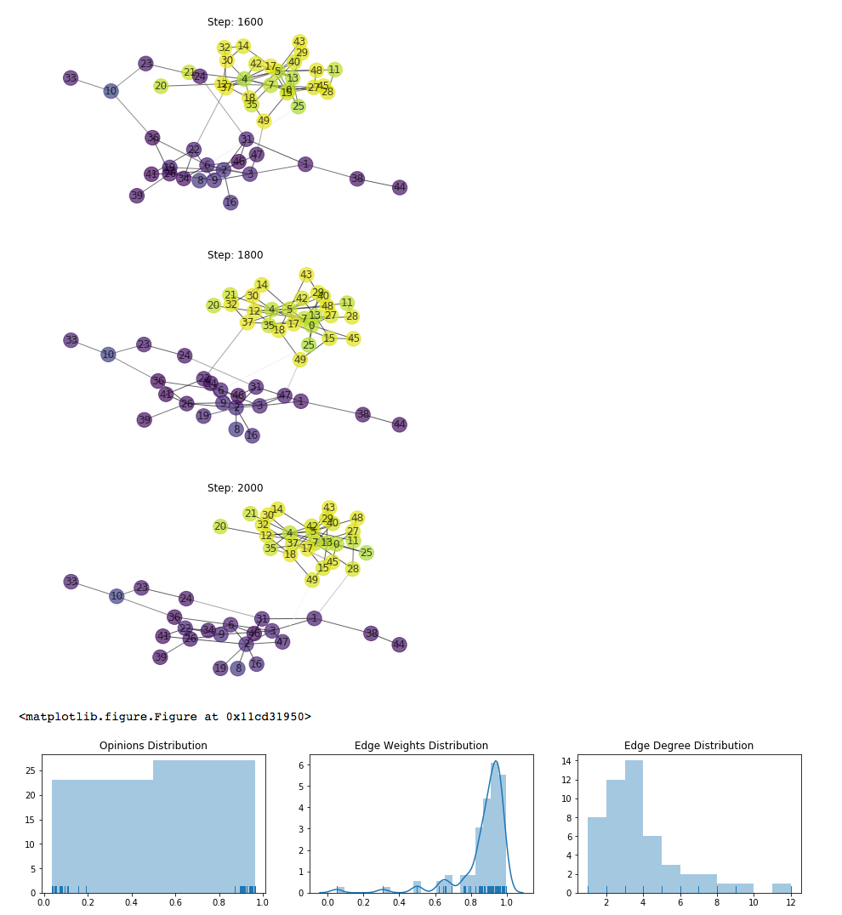 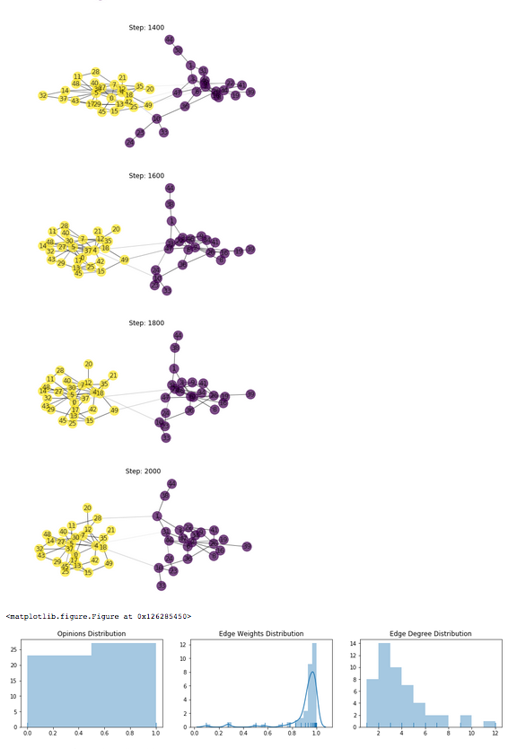

# Appendix D: Simulation Results Example – Divergence.

Here is an example for a simulation with theoretically sound parameters: acceptance latitude at 0.5 with variance of 0.1; noncommitment latitude of 0.1 (so that rejection boundary above 0.6) with variance of 0.1, misperception error biased by 0.15 and a small misperception error variance of 0.05. The nodes separated into clusters between steps 10,000 – 15,000 and got more extreme in their opinions since the connections between the clusters at latitudes of rejection made the nodes diverge more their opinions as a contrast effect. From the parameter progressions plot, we can see that the opinions slowly diverged, with some constant parts, which are likely due to staying at the latitude of noncommitment. The weights either quickly dropped and vanished (for the far-away nodes), but mostly increased (for the in-group nodes), and thus the interactions were mostly for nodes with small gaps (in-group) rather than between groups.

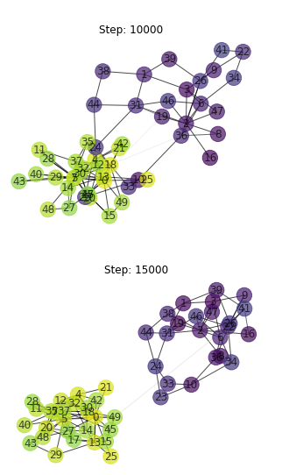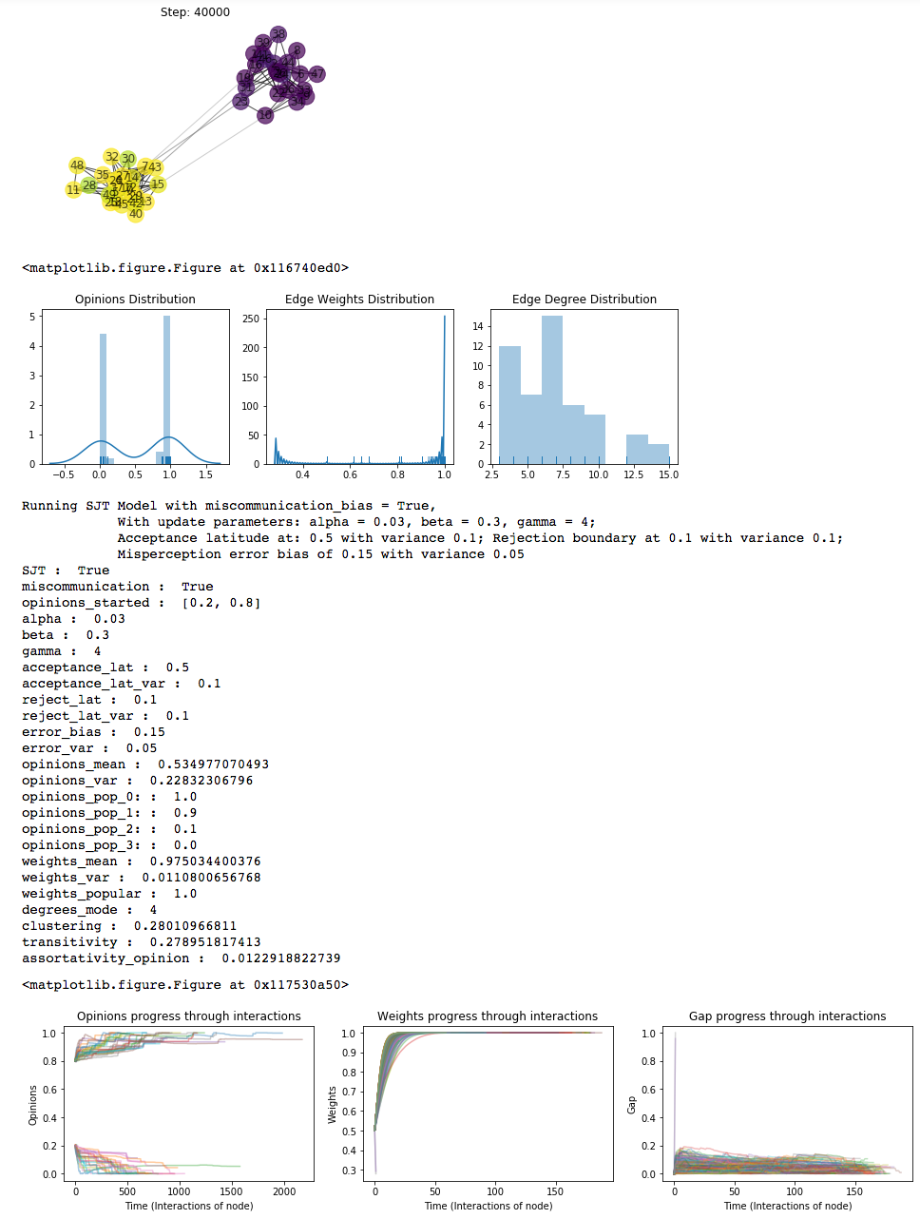

# Appendix D: Network Parameter Regression Results

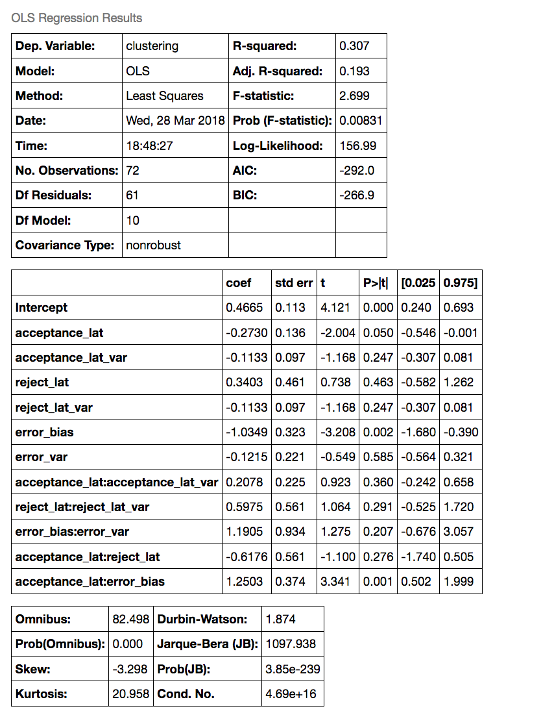

# Appendix E: More Detailed Effects of Changing Parameters

* Increasing error variation:
  1. For low acceptance, low latitude variation, low error bias:
     1. Increased rate of opinion change
     2. Reduced gaps more quickly
  2. With high error bias, increasing error variation
* Increasing error bias:
  1. Opinions sometimes changed to the other extreme.
     1. 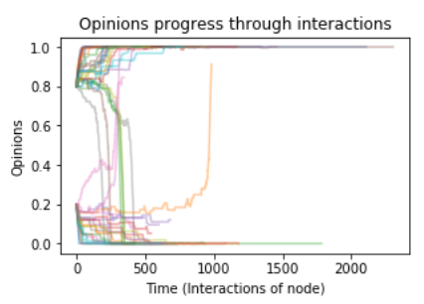
  2. Gaps sometimes increased after a long while
     1. 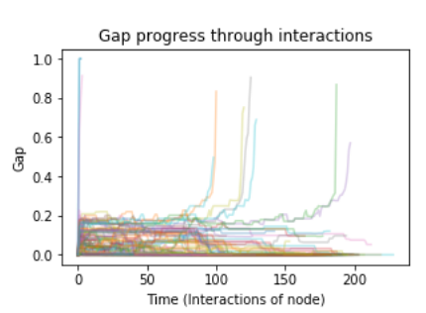
* Increasing variation in latitudes boundaries
  1. With low error and low error variance, low acceptance and noncommitment latitudes (wide rejection latitudes) – Caused **dispersion** in the model and therefore removal of edges (for bigger gaps) and thus **disconnection of nodes**; so that there are no clear clusters, opinions are more widely distributed across the range (0,1); the LLC (largest component) would be significantly reduced which makes percolation potential weaker.
     1. 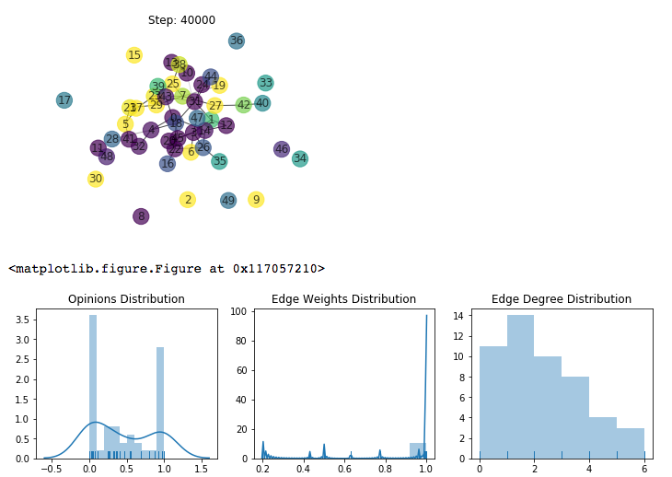 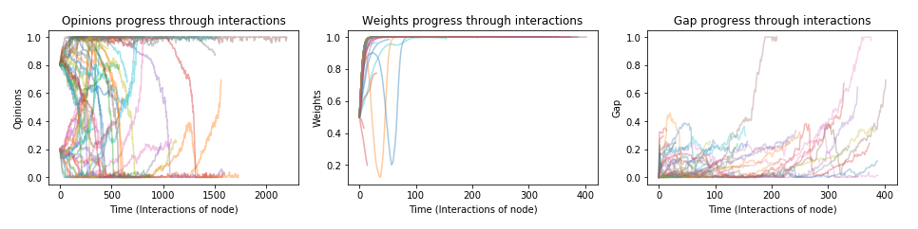
  2. Increasing the *misperception* *error variation from 0.15 to 0.3* but keeping its bias low, the network interestingly diverged again into clusters (with relatively higher in-class variation around 0.2, yet still very distinct clusters). The effect of the variation in perception of opinion might balance or cancel the effect varying the latitudes. The progression of opinions, weights and gaps was still more varied and increasing over time as with the small error variance, in contrary to all attempts with smaller latitude variability.
     1. 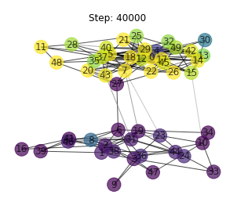
  3. Increasing the error bias from 0.15 to 0.3 while keeping varied latitudes (with a low baseline) caused both *dispersion and a significant amount of completely disconnected, isolated nodes.* (11)
     1. 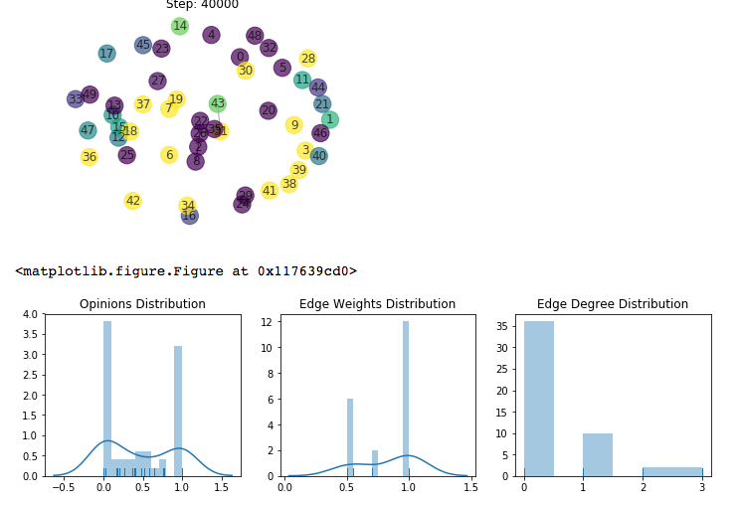
     2. 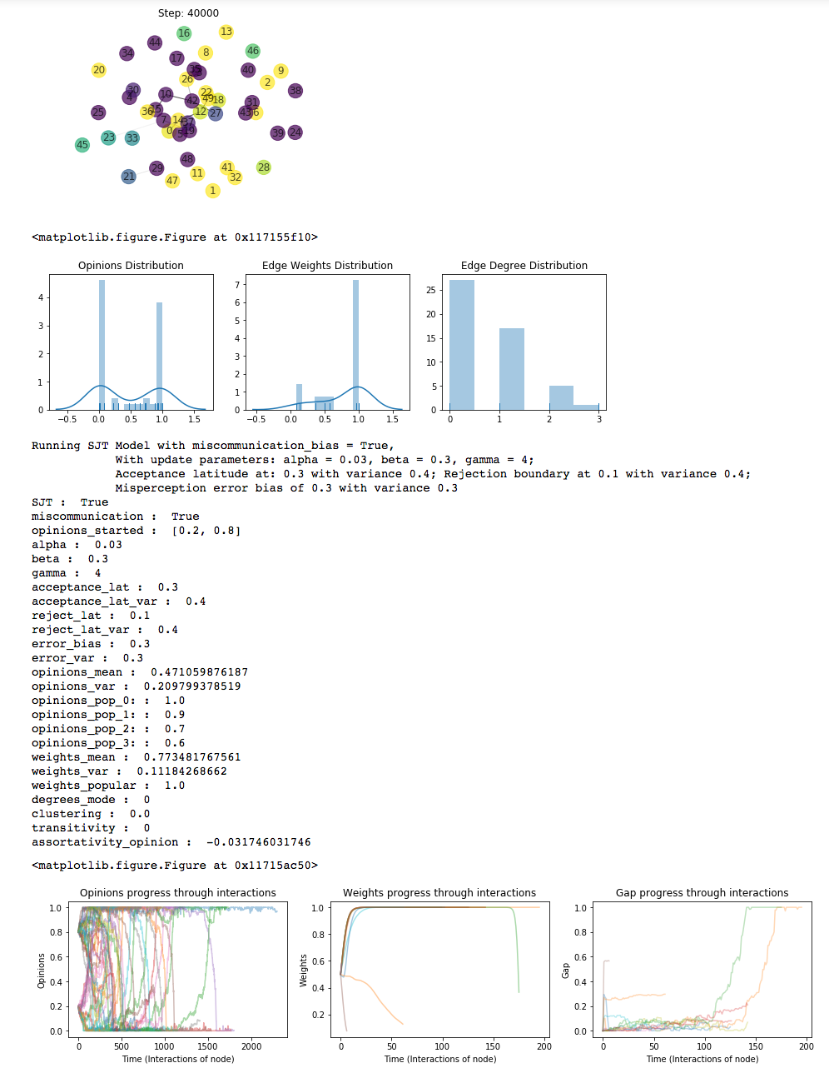
     3. With increased latitude of noncommitment, the dispersed opinions concentrated around 4 opinion value clusters; although they were mostly disconnected so they are not really a clustered connected component.
        1. 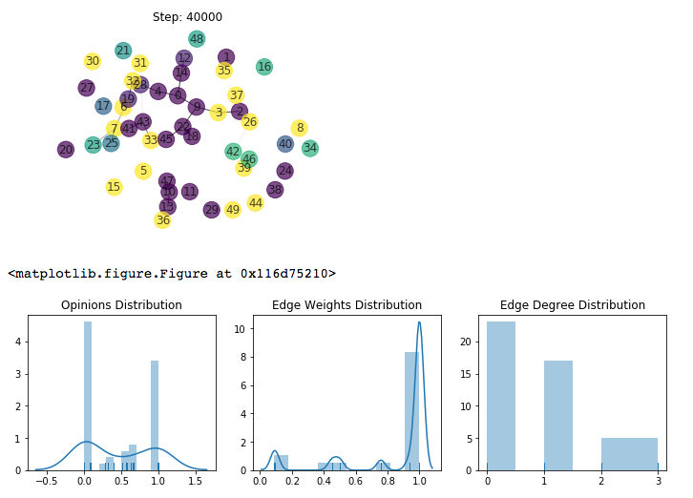
  4. Increasing noncommitment latitude (thereby decreasing rejection latitude) caused divergence to 3 clusters: around opinions 0, 0.5, and 1; with the extreme clusters being vary varied within themselves, and the middle-way cluster be smaller and more cohesive (about their lack of opinion). Initially the networked diverged to 2 clusters with 1 very varied one, until it split off.
     1. 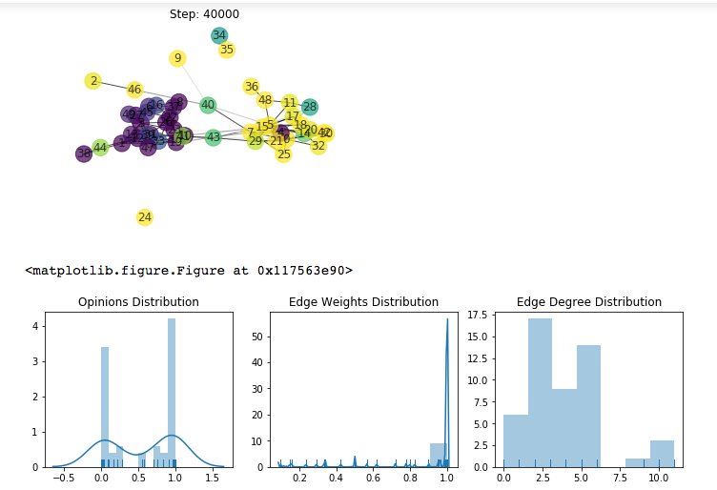
     2. Interestingly, increasing the variation in the misperception error, again resulted in splitting off to 2 clusters only, albeit with medium-high in-class variation and most opinions being less extreme than usual, around 0.05 and 0.95. The opinion change progression was highly fluctuating thus remained overall more constant then going in one direction.

# Appendix F: Results Examples

Below are categorized examples of characterizing or interesting end-states of the SJT simulation. Each result contains the last image of the network, distribution plots of key metrics, and printed out all of the parameter settings and key metrics.

## Convergence

Weak convergence

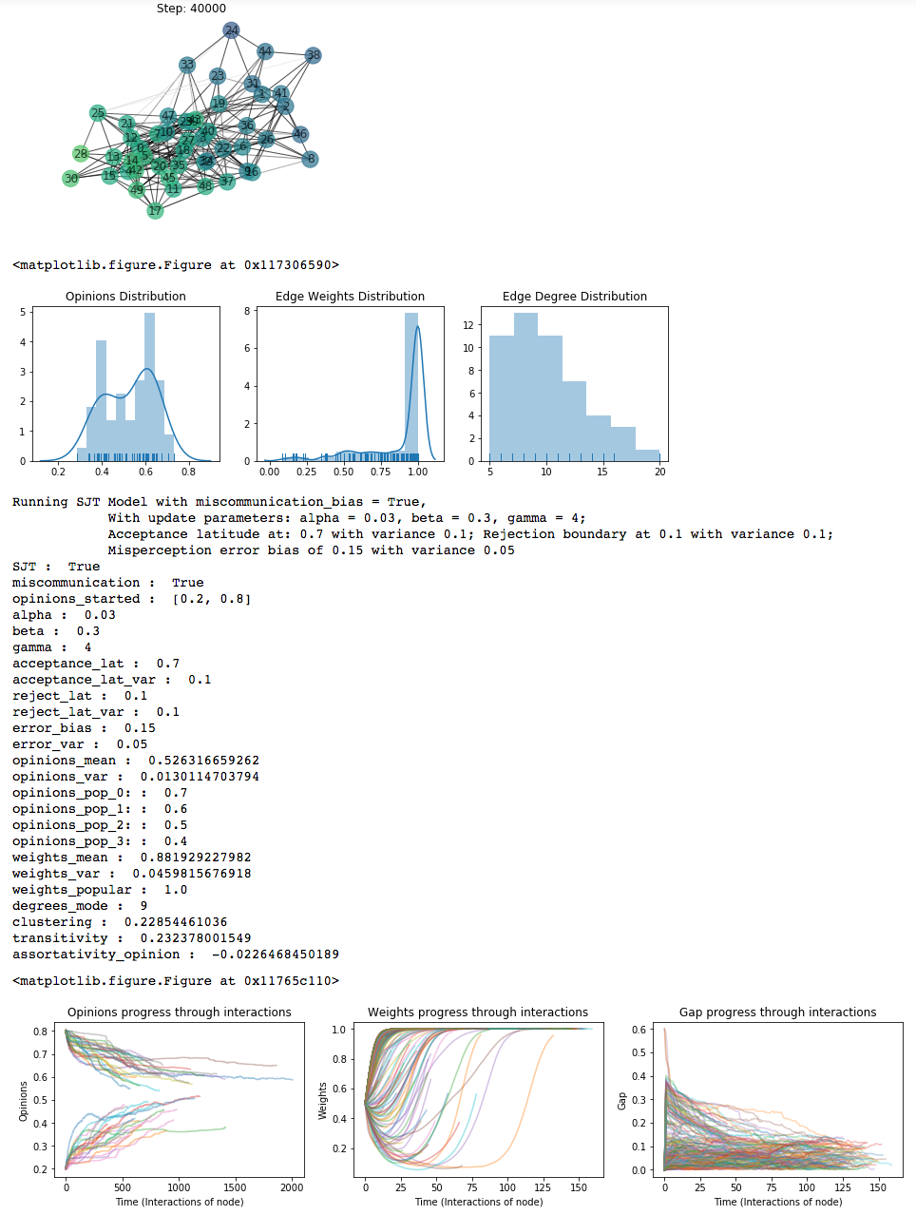

Strong convergence

### Critical Values: on the Verge of Convergence

Unclear direction with large latitude variability

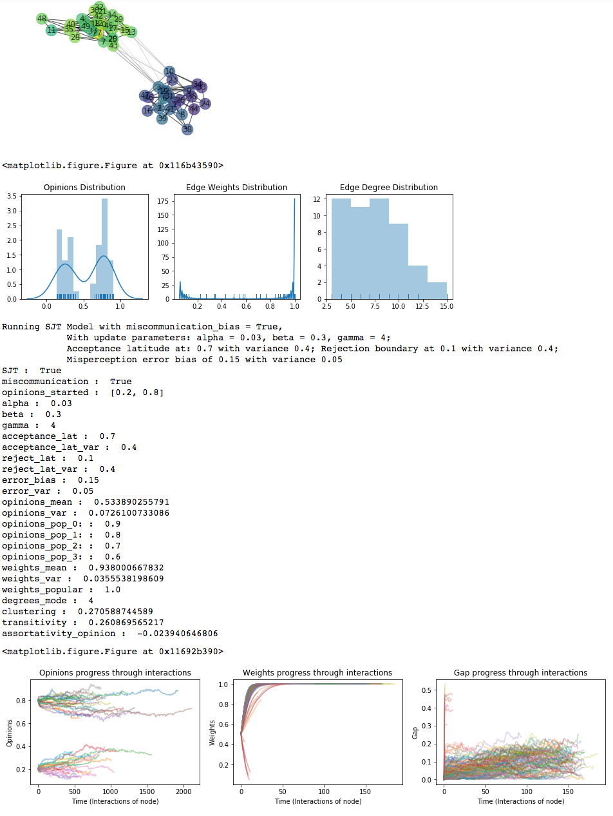

Stagnation

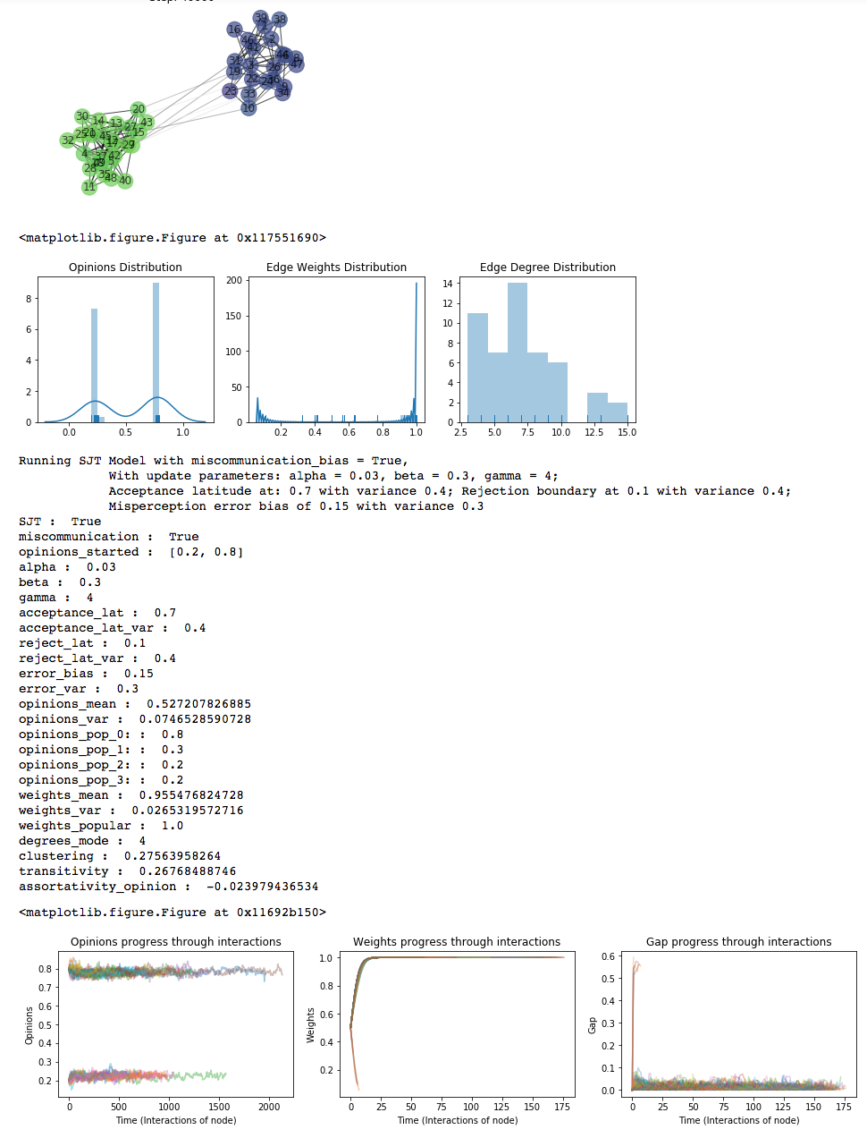

### Dispersion

When increasing the variation of the latitudes, we encounter dispersion.

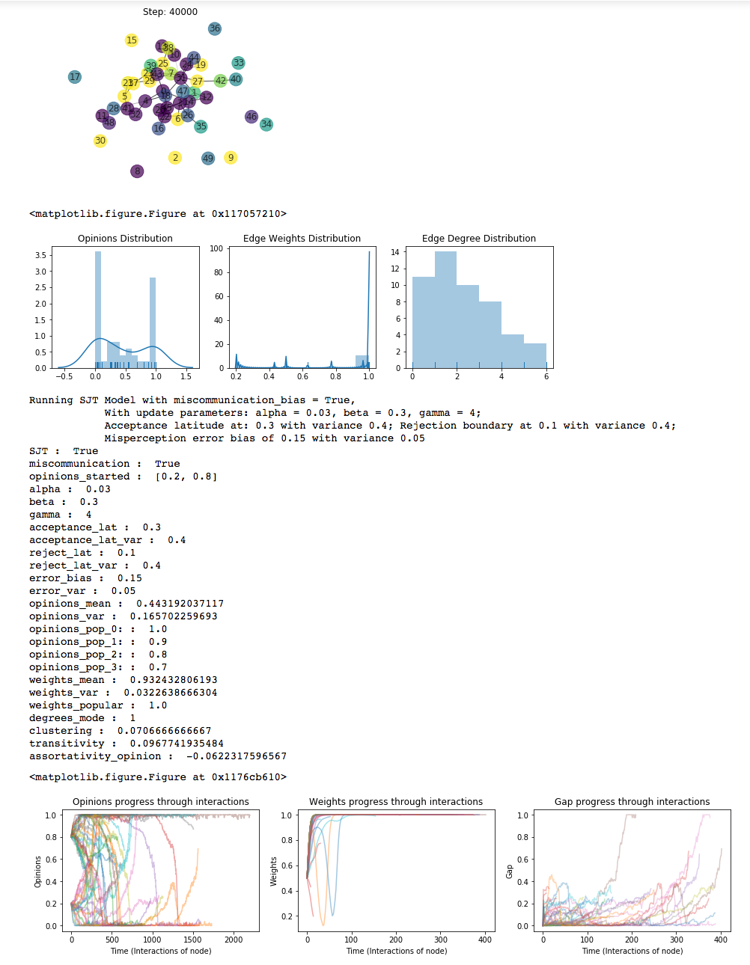

### Dispersion and Disconnection

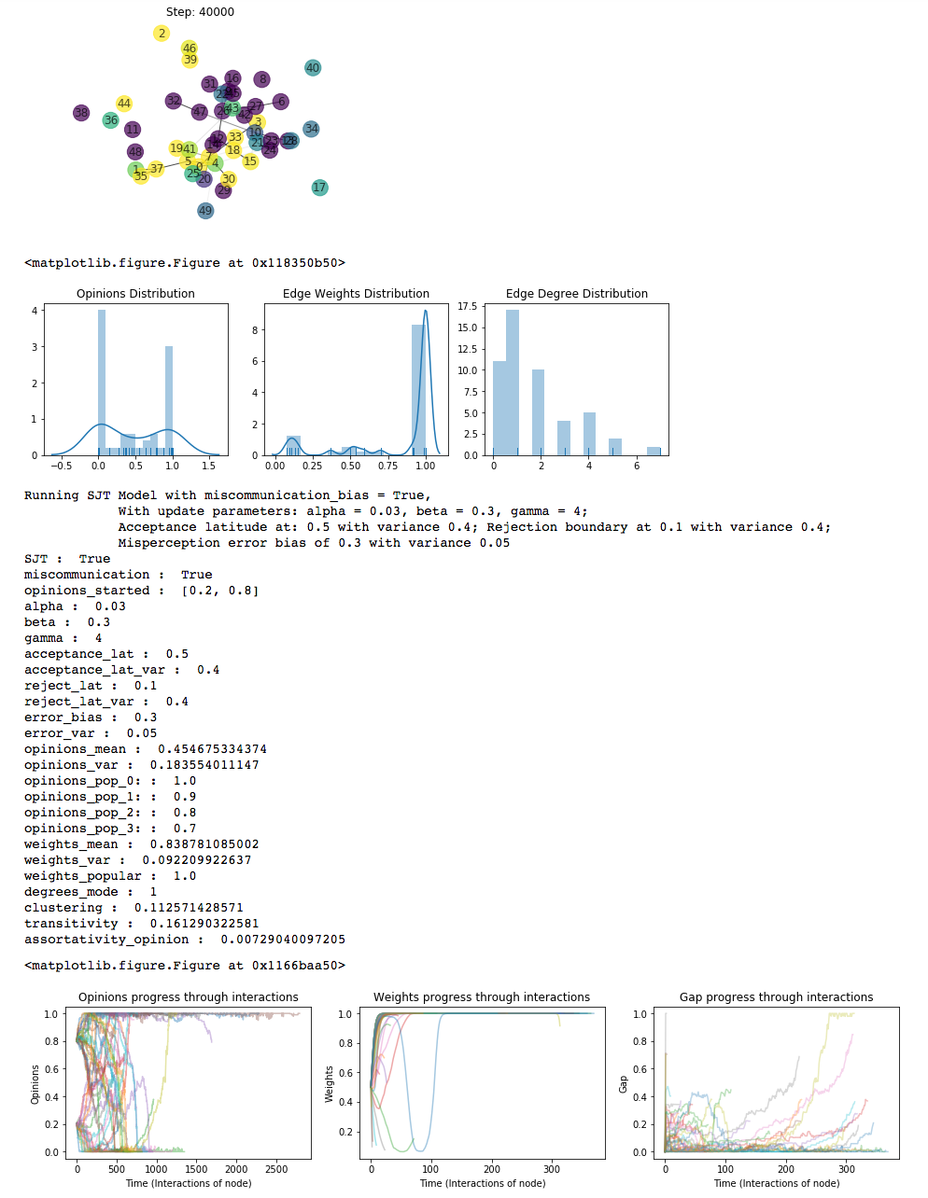

## Stagnant Opinions

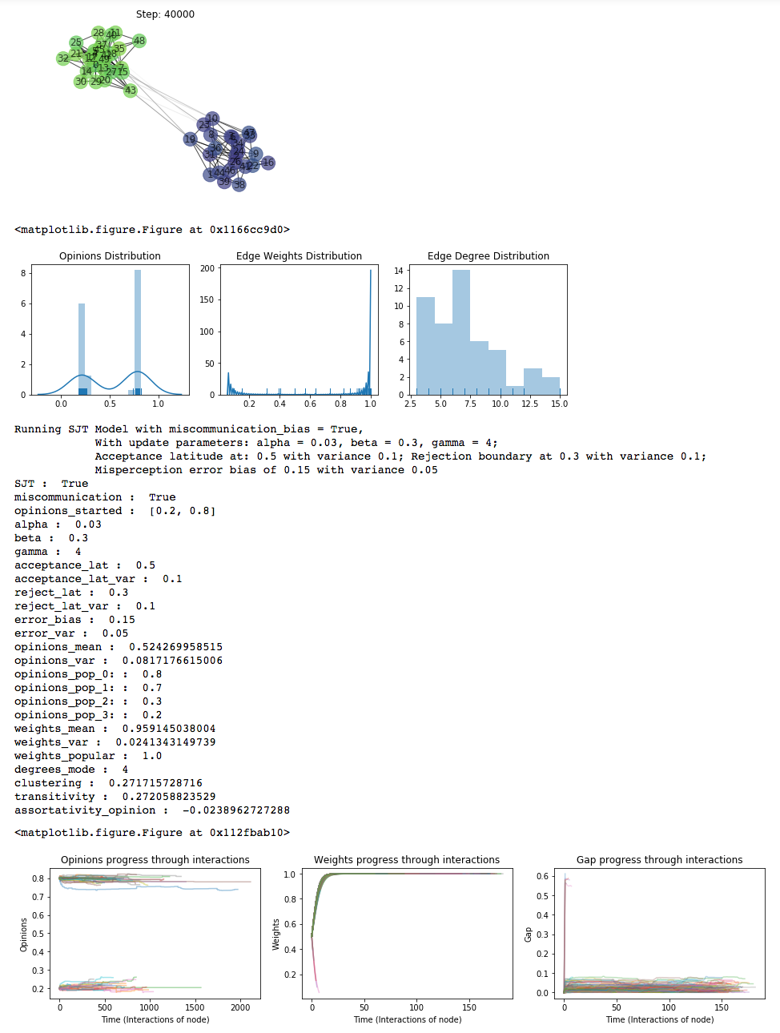

### Simultaneous Divergence and Convergence

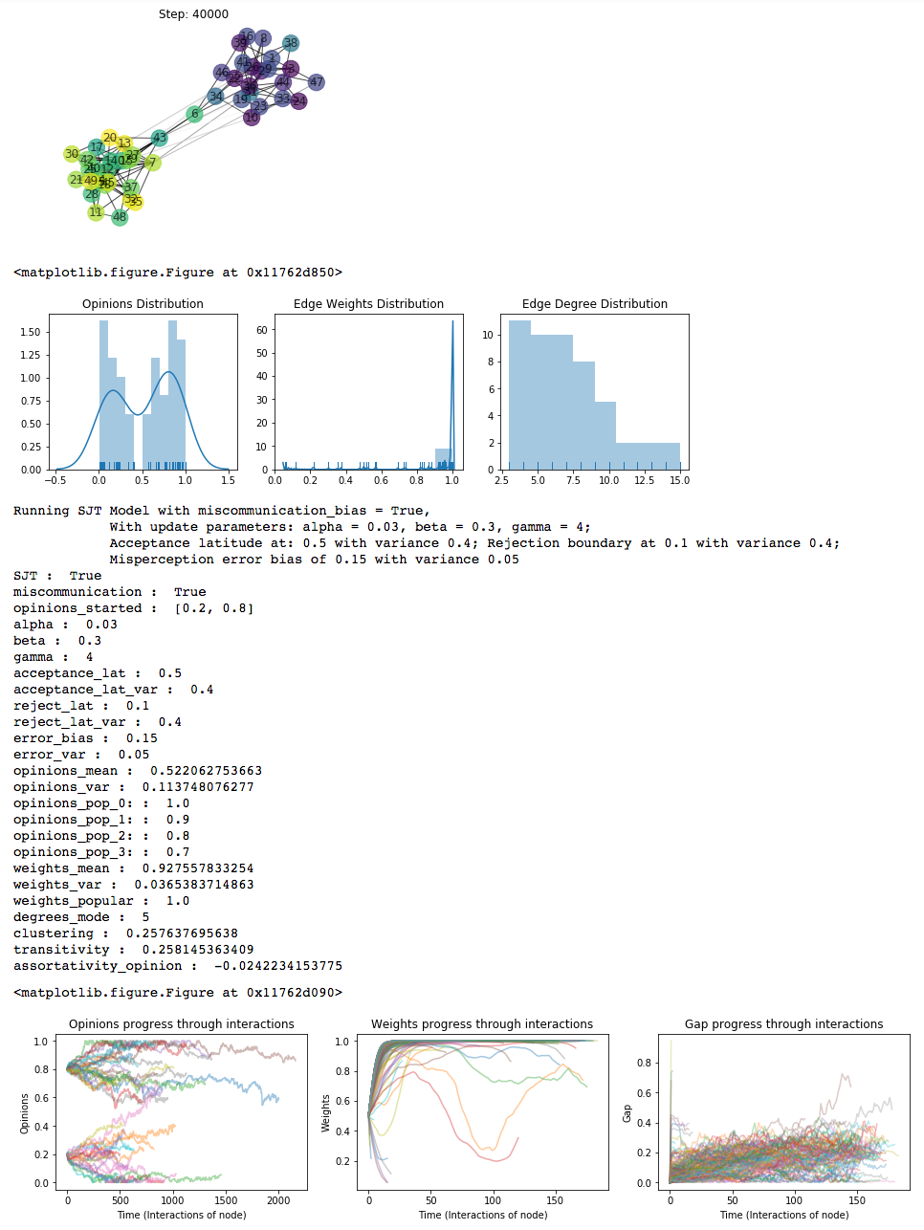

Both divergence and convergence creating both extreme clusters and wide distribution, another cluster around 0.4.

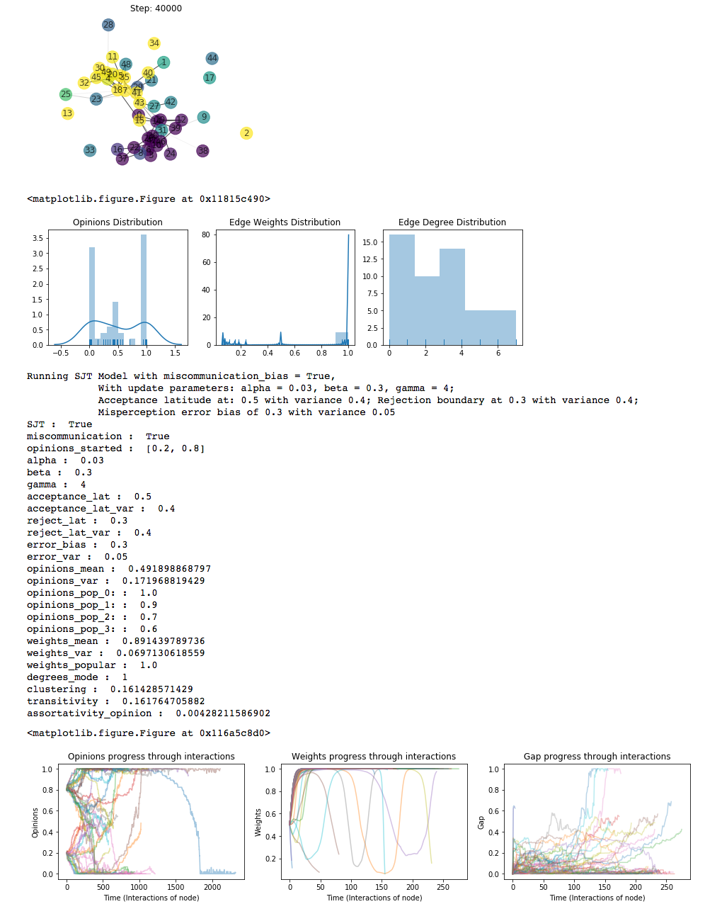

1. In this scale of opinions between [0, 1], the communicated opinions might be miscommunicated at around 10%, and less commonly around ~20% of its value. To model the assimilation and contrast bias, I determine that this distribution of opinion with miscommunication error will be shifted 10% according to the person’s latitude. If the opinion is within the acceptance latitude, it will be misperceived as closer (assimilation). If it is within the rejection latitude, it will be misperceived as farther (contrast). To achieve a realistic error with variance of 10% for most cases but of up to 20% for 95% of the cases, this translates directly using 1.96*standard to an error mean at µ = 0.1 (as bias), and variance of = 0.1. The following figure shows histogram of 1000 draws from this distribution around original opinions of 0.2 and 0.8, opinion values later used in simulation, (marked with a green dashed line), and resulting with a normal distribution around a perceived mean which is 0.1 closer in each side, assuming that they are within each other’s latitude of acceptance.
2. [Sherif, 1963](http://psycnet.apa.org/doiLanding?doi=10.1037%2Fh0043022); [Hovland, Carl I.; Sherif, Muzafer (1980)](https://books.google.co.in/books?id=_pNxPwAACAAJ&dq=0313224382&hl=en&sa=X&ved=0ahUKEwiP7u2foY_aAhVMqY8KHXVzA-8Q6AEIJjAA)*;* [Ledgerwood, 2007](http://psycnet.apa.org/doiLanding?doi=10.1037%2F0022-3514.93.6.940)